DECENTRALIZED DATA FUSION IN PEER-TO-PEER ENVIRONMENT

M.Sc. Sergiy Nazarko
University of Jyväskylä
FINLAND

M.Sc. Annemari Auvinen
University of Jyväskylä
FINLAND
Prof. Jarkko Vuori
University of Jyväskylä
FINLAND
M.Sc. Mikko Vapa
University of Jyväskylä
FINLAND

ABSTRACT

This paper describes decentralized data fusion system in peer-to-peer environment. Decentralization plays crucial role in military services. If there is no central in the system then the risk of critical failure is minimized. Nowadays peer-to-peer networks and services are one of the most evolving technologies. P2P sensor networks with data fusion capabilities built on mobile platform will become an up-to-date solution in applications of military defence. This article includes theoretical and practical aspects of decentralized data fusion system implementation in multi-sensor peer-to-peer environment. Two algorithms have been taken into consideration during the research. They are Kalman Filter [3], and Transferable Belief Model [6]. In this article we will concentrate on the Kalman Filter.

DECENTRALIZED DATA FUSION SYSTEMS

Decentralized Data Fusion (DDF) is a technology, concerning the problem of how to fuse data from multiple sensors in order to make a more accurate estimation of the environment. Applications of such systems vary from military applications, to non-military. Examples can be found in Table 1.

Table 1. – Examples of data fusion application
Military applications | Non-military application
Target tracking and identification | Machine vision
Data association | Medical decision support systems
Situation assessment | Environmental monitoring

Decentralized data fusion system is a collection of processing nodes, which have different tasks to perform (like in the developed prototype where sensor nodes and fusion nodes exist. No one node has knowledge about whole topology of the network. Decentralized data fusion systems (DDFS) have an organization that can be described as follows:

- Collection of processing nodes
- None of the nodes has knowledge about the overall topology of the network
- Each node performs a specific computing task
- No central node exists that controls the network

The decentralization in data fusion is important because it provides reliability and flexibility. Reliability is achieved because there is no central node exists, and loss of nodes or links doesn’t affect the functioning of whole system. Flexibility of such systems is explained by following characteristics: nodes can be added or deleted by making only local changes; only establishment of links to one or more nodes is needed.

Figure 1. P2P sensor network

This paper concentrates on multi-sensor data fusion system. Fused data from multiple sensors provides several advantages over data from a single sensor [1]. First of all if several sensor nodes are used to observe similar data, for example in target tracking, combining the observation will lead to improved estimation of target position, velocity and so on. Multi-sensor data fusion includes integration of data from multiple sensors, producing different data with different level of precision. Furthermore, data can be even conflicting. The problems, which data fusion and data fusion algorithms try to solve, are not trivial. Data fusion can be viewed as a set of problems [2], as follows:

- Fusion of temporal information – time always causes problem to engineers, because it deals with dynamics. Two added problems arise: effective description of past, and fusion of past data with current situation.
- Fusion of information from different sources – for example if we have one clock it’s easy to describe our knowledge about time, but if other clock provides different time estimate then we have a problem: how to combine data from both clocks and what’s their accuracy becomes a problem.
- Fusion of dissimilar information – information, which should be fused, could be represented in several ways.

KALMAN FILTER

Kalman filter [3] is optimal linear recursive data processing algorithm in least square means [4]. In this case word filter means a data processing algorithm, and recursive says that this filter doesn’t require all previously measured data to be kept in the storage and be reprocessed every time when new measurements are put to the system. This plays a crucial role in implementing Kalman filter, which isn’t overloaded with often-unnecessary data.

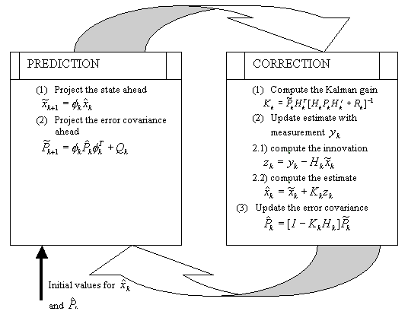
Figure 2. Kalman filter processing

The goal of Kalman filter is to estimate state of some system from measurements, which may contain random errors. The majority of Kalman Filter applications are related to problem of tracking some targets in the observation space. Actually this method is a set of mathematical equations, which provide an effective computational solution of the least square algorithm. All Kalman computations can be thought as some manipulations on the normally distributed probabilities. Figure 1 shows the steps and basic equations in Kalman filter processing.

PRACTICAL ASPECTS OF IMPLEMENTING DDFS

In order to get clear picture about the usage of decentralized data fusion systems prototype application has been developed. Decentralization was built on Chedar (Cheap Distributed Architecture) peer-to-peer platform [5]. The DDFS consists of four components namely P2P Real-World Simulator, P2P Sensor Network, Situation Display and P2P Studio (Figure 3).

Real-world simulator is an external application, which is used for generating coordinates of target movement. In the first version we track only one target. Observation space is temporarily divided into 6 sectors. Every sector may contain any amount of sensor nodes. There is a possibility to create different scenarios of target movements. Sensor measurement at a given time generated by this application is stored in XML-files as follows:

<?xml version="1.0" encoding="UTF-8"?>
<resources xmlns:xsi="http://www.w3.org/2001/XMLSchema-instance" xsi:noNamespaceSchemaLocation="resources.xsd">
<location-resources>
<coordinate stamp="1">x7y13</coordinate>
<coordinate stamp="2">x6y16</coordinate>
<coordinate stamp="3">x3y19</coordinate>
<coordinate stamp="4">x1y17</coordinate>
</location-resources>
</resources>

P2P Sensor Network is a collection of sensor nodes, which are built on Chedar platform. They send information to data fusion node, which also is a part of the network.

Situation display is used for showing different trajectory of target movements:
- Real trajectory (stored in XML-files generated by Real World Simulator)
- Measured trajectory (given by sensors), sensor data is corrupted by noise
- Estimated trajectory (given by Kalman filter)
- Predicted trajectory (given by Kalman filter)
For displaying the situation data fusion is needed. Now situation display is combined with data fusion in one node.

Target trajectory is displayed dynamically, when Kalman filter gives new sets of coordinate values. Fusion node collects data from sensors and combines them to obtain a picture of the whole observation space.
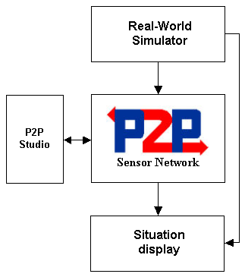
Figure 3. Schema of the developed DDFS

P2P Studio can be used for generating network failures, and using this tool we can discover how the quality of estimation depends on the number of sensors and failure rate. The main feature of the developed system is one Chedar-application that takes care of sensor measurements and data fusion. There is possibility to run multiple data fusion nodes simultaneously in order to increase fault tolerance and reliability of the system. Another important feature is that at any time any sensor node can switch to processing node if needed. Therefore even if some processing nodes crash other sensor nodes can take the work of the crashed ones.

Current version of developed DDFS has few weaknesses. First of all it uses request-reply architecture, ibecause of the nature of Chedar, which basically was designed as platform for finding resources. Therefore the system doesn’t work in real-time but has it’s own time (timestamp), meaning that every second fusion nodes flood the network with resource-request message. This can be avoided if sensors would send coordinates when they are received). Another weakness is that if we are running only one fusion node and it crashes, new fusion node will start with initial parameters of Kalman filter, and time is needed for adjusting filter’s parameters. This can be avoided by moving Kalman filter parameters from one fusion node to another.

Figure 4 depicts the work of current version of the developed DDFS. As we can see bold line with boxes depicts the real trajectory of some target. The measured trajectory, which received by adding some noise to real trajectory within the sensor, is depicted by thin line with triangles. Estimated trajectory, which is computed by Kalman Filter showed by dashed line with circles. And predicted trajectory also computed by Kalman filter is depicted by thin line with diamonds. In the current version inaccuracy of all sensors (level of noise) can be adjusted using the Noise buttons. Parameters of Kalman filter can be adjusted usong the Tuning buttons. Parameters MSE(x) and MSE(y) shows Mean Square Error between estimated trajectory and real trajectory of the target.

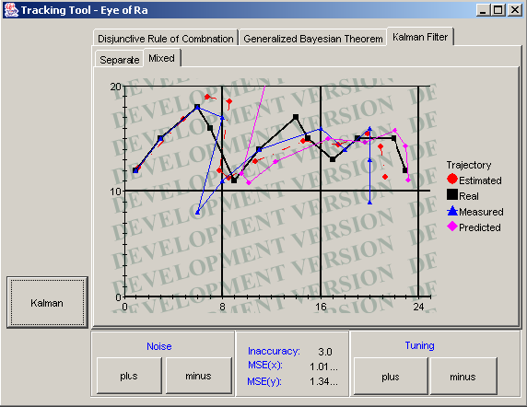

Figure 4. DDFS in work

CONCLUSIONS

Nowadays peer-to-peer networks are one of the most fast evolving technologies. Particularly important and interesting issue is using P2P network in dynamic environment, where Chedar platform can be used. The research described in this paper is still going on and a lot of interesting issues are coming into the scene. For example analyzing the test version of the prototype in dynamic environment is one of such issues. Of course our DDFS will evolve, next step in this direction is adding multiple targets into simulation. Multi-target tracking requires target identification and data association; Transferable Belief Model [6], which can be used for these purposes, and it will also be implemented in the future.

REFERENCES

[1] David L. Hall, James Linas, “Handbook of multisensor data fusion”, N.J. : CRC press, 2001.
[2] Korpisaari P., “Studies of data fusion techniques for multitarget tracking”, Tampere University of Technology, 2001.
[3] Kalman, R.E. ”A New Approach to Linear Filtering and Prediction Problems”, Transaction of the ASME – Journal of basic Engineering, pp 35-45 (March 1960).
[4] Maybeck, Peter S. “Stochastic Models, Estimation, and Control”, Volume 1, 1979, Academic press, Inc.
[5] Auvinen, A., “Topology management algorithms in Chedar peer-to-peer platform”, Master’s Thesis, 2004.
[6] Ph. Smets, “Target identification based on the Transferable Belief Model interpretation of Dempster-Shafer Model Pars1: methodology”, IRIDIA, 2001.

 | EUROOPAN UNIONI

