Special Assignment

Using MatLab Self-Organizing Map (SOM) toolbox for investigation of NeuroSearch

Student:  Supervisor: | Yevgeniy Ivanchenko  Mikko Vapa

Department of Mathematical Information Technology

University of Jyväskylä

Abstract
The assignment represents results of investigation of statistical data obtained from NeuroSearch (trained with evolutionary algorithms). As analyzing tool Self-Organazing Map (SOM) toolbox for MatLab was used. Also the assignment briefly describes method for processing of data obtained from simulation using Breadth-First Search (BFS) algorithm. Results of this processing will be used later for training of Multi-Layer Perceptron (MLP).

Introduction
The Self Organizing Map (SOM) is powerful tool for solving various tasks such as classification, analyzing, forecasting etc. Mostly the SOM is known as an unsupervised algorithm, but there is also a supervised implementation of SOM. The SOM combines itself both vector quantization and vector projection algorithm. The SOM allows mapping high dimensional space of input vectors into output low dimensional (usually two dimensional) grid. After using this algorithm similar vectors from the output space are located near each other in the output space.

There are two approaches for training of the SOM: sequential and batch version.
1) Sequential training algorithm is iterative process. In each step we chose randomly one vector and than we calculate distance between all neurons and it. After that we update weights of the closest neurons.
2) Batch algorithm is also iterative, but the whole data set is used on each step. During training data set is spread according to Voronoi regions. After that we change weights of neurons using average weights of the vectors.

About MatLab
MatLab is powerful tool for realization of different mathematical tasks, data processing and visualizing information. MatLab is widely used for decreasing time of development; it allows fast comparing of different results and finding the best results.

MatLab provides the following features:
1) Fast and efficient implementation of matrix calculus
2) Graphics for representing information
3) Interactive visual environment for programming
4) Interfaces with external languages (C/C++, Java)
5) Connection to databases

Special sets of functions (toolboxes) are present in Matlab. These toolboxes play main role for solving particular tasks. Matlab contains the following base toolboxes:
1) Communication toolbox
2) Control system toolbox
3) Fuzzy logic toolbox
4) Image processing toolbox
5) Neural network toolbox
6) Optimization toolbox
7) Signal processing toolbox
8) Spline toolbox
9) System identification toolbox

In this work we used SOM toolbox (developed in Helsinki University of Technology) instead of native neural network toolbox, because native toolbox does not provide all the required functions for investigating and analyzing data.

Investigating of NeuroSearch with help of SOM
NeuroSearch is Peer-To-Peer (P2P) resource discovery algorithm. It makes decisions about further forwarding of each packet in particular situation. The decision is based on the output of the neural net (3-layer perceptron).

Investigation of NeuroSearch is based on data, which was collected during simulation of NeuroSearch that was trained using evolutionary computing. The data was represented in the XML format. To convert data from XML to MatLab format, XML parser was written using PHP language.

To investigate behavior of NeuroSearch we used the following features from SOM toolbox:
1) We built U-matrix and added distribution of all samples on this matrix to investigate structure of clusters.
2) We built component plane to see effect of each variable on particular decision.
3) We built projection of resulting map. It might help investigate the cluster structure.
4) We built distribution of all variables on the map (bar plane).
To get the above information small scripts were written on MatLab script language using functions from SOM toolbox.

U-matrix is common way to represent information about the map. U-matrix shows distances between its elements. Due to this we can investigate the distribution of cluster structure on the map. To show real distribution of the decisions on the map, we added ‘hits’ on U-matrix. To visualize them, we used ‘pie’ structure. This structure shows percentage of presenting input elements near each map unit. Also we used here hexagonal map structure with distribution of labels. Labels were obtained from the final map using method vote. This method calculates number of entries of each element in each region near each member unit, and after that uses label with the biggest number of entries.

We made experiments with different sizes of maps. Size of the map mostly influence on scaling factor of representing the output space. Thus we had to find compromise between good visual appearance of the map and good representation of the map. After series of experiments we found that default size of the map (42x20) gives quite good representation of results. The default number of neurons is calculated using heuristics:

$\text{Number} \text{of} \text{Neurons}=5∗\sqrt{\text{Number} \text{of} \text{Samples}}$ (1)

Also output map should not have square form. One side of the map should be bigger than other approximately twice.

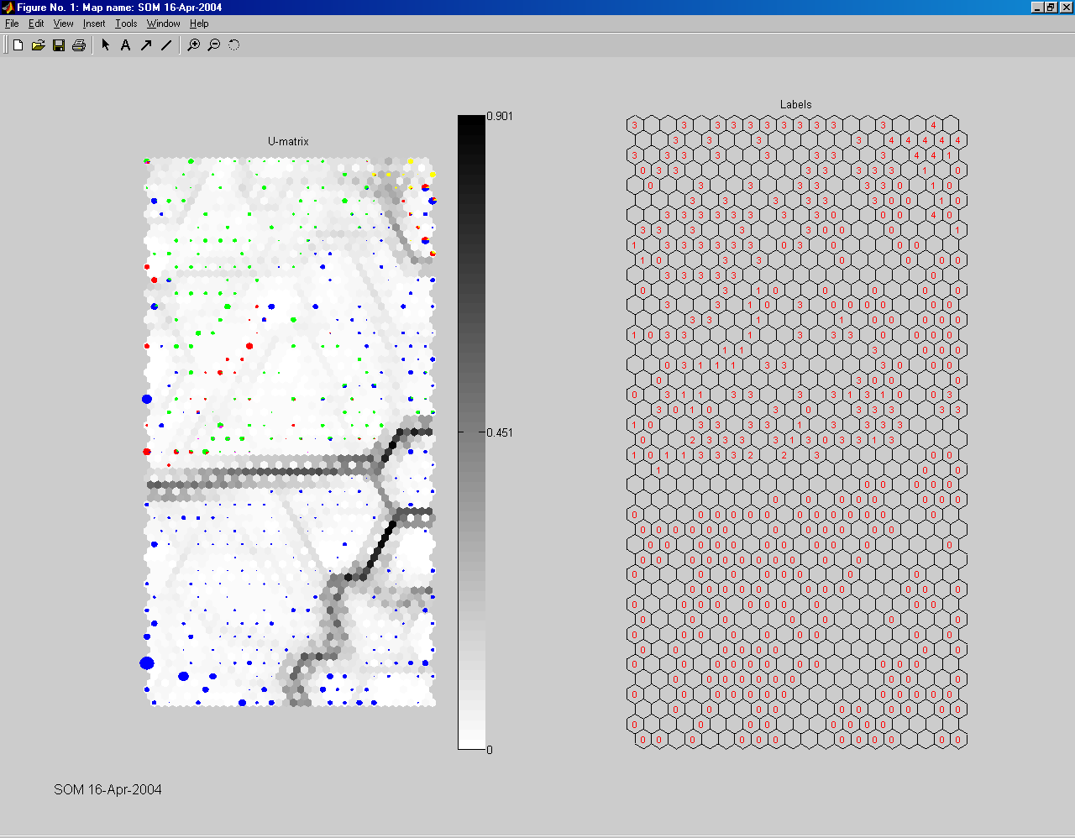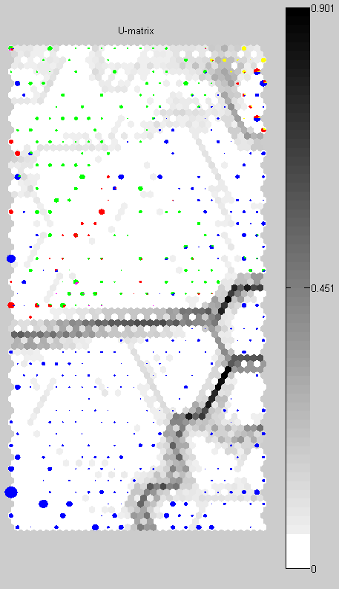
Figure 1 – U-matrix

On the Figure 1 U-matrix with hits (the right side of the figure) and labels’ distribution (the left side of the figure) are shown. Labels are ranged from zero to four from the lowest output of neural net to highest output. Labels ‘3’ and ‘4’ are responsible for ‘forward’ decisions and ‘0’,’1’ and ‘2’ of ‘not forward’. ‘Hits’ have different color on the U-matrix:
1) blue color accords to label 0
2) red color accords to label 1
3) magenta color accords to label 2
4) green color accords to label 3
5) yellow color accords to label 4
From Figure 1 we can see that three clusters are presented here. Two bottom clusters represent samples where two last variables (Sent and Received) are equal 1. As we can see NeuroSearch made excellent division of these samples from others where these variables are equal to zero. That means that NeuroSearch learned that it is not efficient to send packets back to the sender or send them using links that already were used to send this packet. The upper cluster represents more interesting information about NeuroSearch. Here we can see several subclusters with overlapped samples. This might be caused by low quality training or influence of some variables, which were not able to provide efficient information about environment. These variables could react with each other and as result NeuroSearch could learn environment and could not learn rules from this environment.

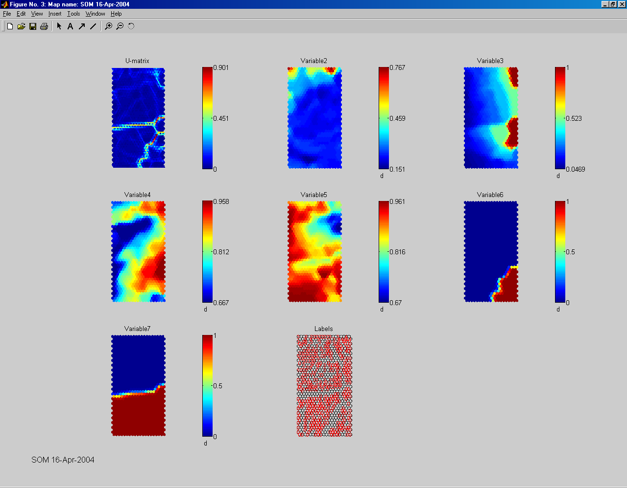
Figure 2 – Component plane
On the Figure 2 we have the following correspondence between variables:
Variable2 – Hops
Variable3 – NeighborsOrder
Variable4 – Neighbors
Variable5 - MyNeighbors
Variable6 – Sent
Variable7 – Received

By analyzing component plane we got more information about the behavior of NeuroSearch. Behavior of variables six and seven confirmed our earlier assumption about these variables. But with other variables situation was more complicated. Comparing variables three and four we can see that these variables are correlated somehow. They have quite similar distribution of color on the map. Variable number three has stricter border than variable number four. But it seems that both of these variables represent the same information from the environment and collaboration of them might help to learn environment and cause decreasing of generalization ability of trained neural net. Comparing variables number two, three, four and five we can extract some rules from behavior of NeuroSearch. It is quite efficient to forward queries with small hops value. But on the left side of U-matrix we can see some areas where NeuroSearch decided to stop further forwarding. These areas cover also zones with low hops value. It might be caused by interaction between variable number five and number three (and as consequence variable number four). These variables have the lowest and the highest value in these areas. This fact might be interpreted as, that NeuroSearch learned it is not efficient to forward queries from high connected to low connected nodes. There is of course some noise in this area, because we do not have any guarantees that NeuroSearch was trained properly (especially if we take into account cooperation between variables number three and four), but it seems that in general this rule quite well describes the behavior of NeuroSearch.

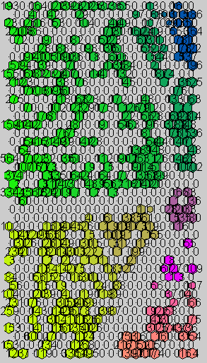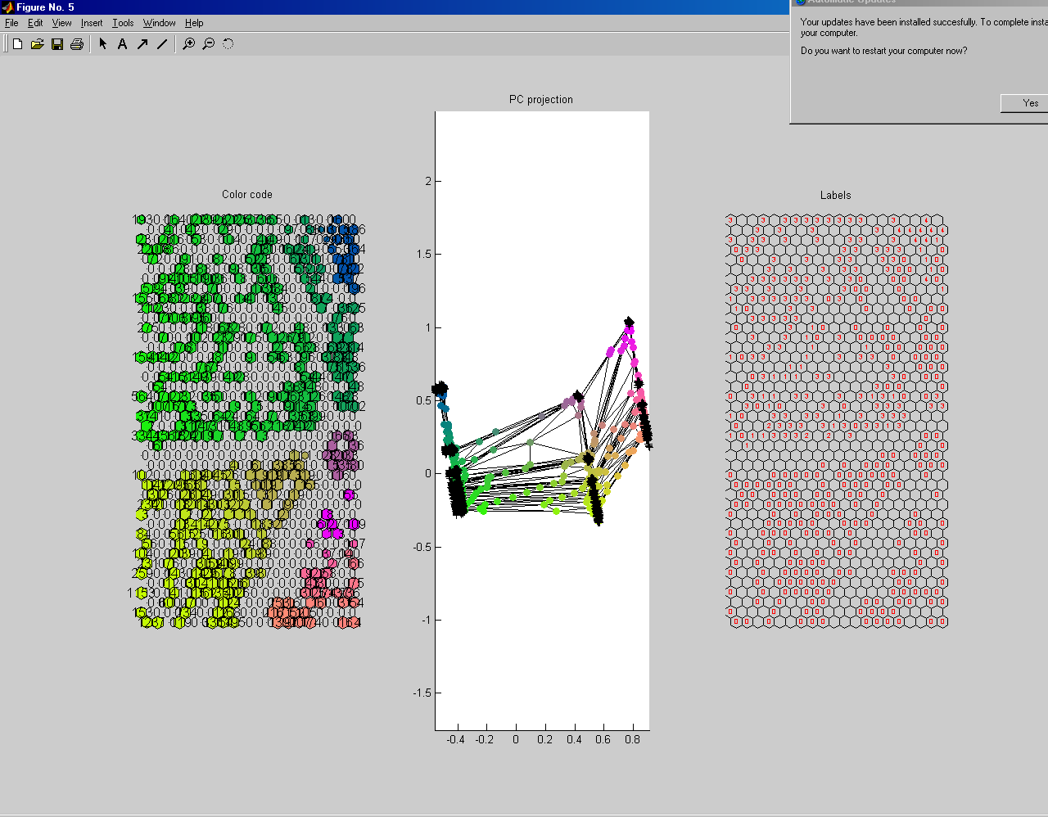
Figure 3 – Color code and PC projection

It seems also that variables, which represent MyNeighbors and Neighbors values, are somehow correlated between each other. If we look more careful on their distribution on the map we can see that there are a lot of areas where these variables are ‘inverted’ variants of each other. Mostly it is not efficient to forward queries when these variables have small values, especially when both of them have small values, but this rule doesn’t work in zones with small hops value. Most interesting subcluster is in the upper right corner. High outputs of NeuroSearch are presented in this area, but also we can see a lot of members from other classes. This is not good sign for us, because this means that NeuroSearch cannot separate clearly decisions from each other.

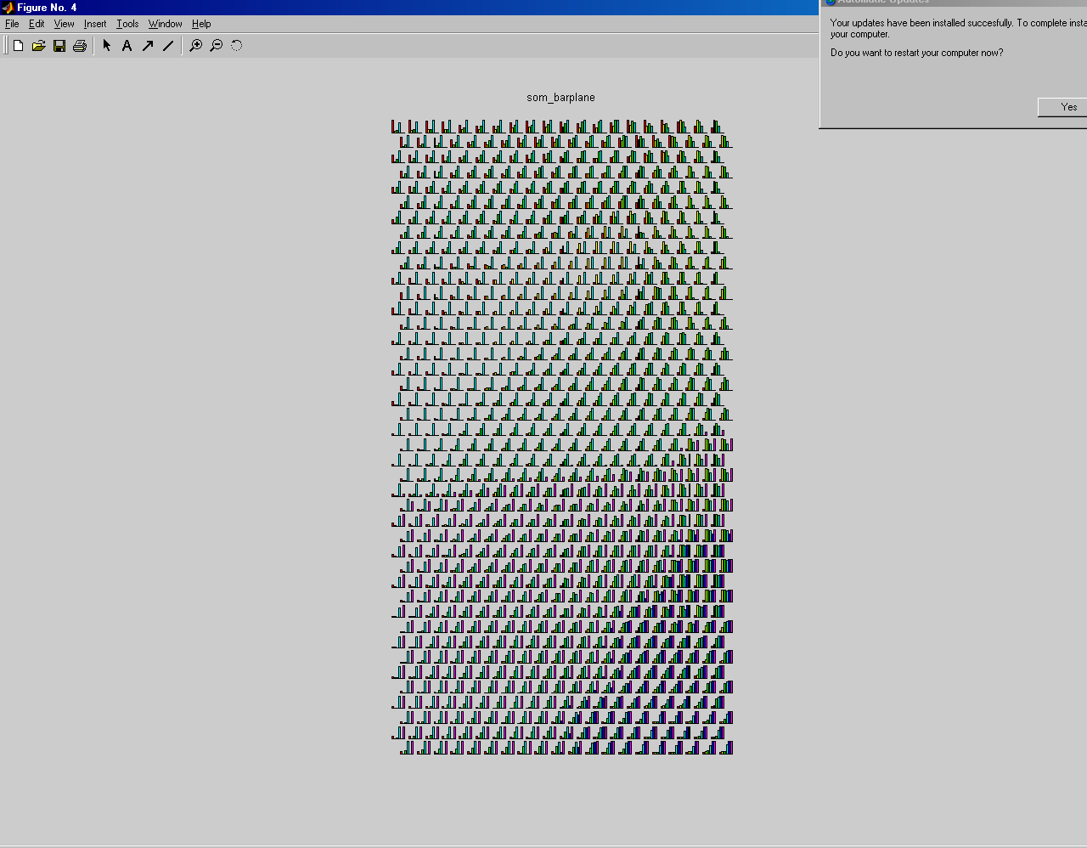
Figure 4 – Bar plane

Let us study more careful this situation. NeuroSearch can easily separate these cases when hops value is low. But when this value becomes bigger NeuroSearch cannot separate them using some general rules. This is definitely a problem and we see consequences of this problem when NeuroSearch revisits several times one node.

PC projection represents distribution of units from the output map with a different color, the color represents distance measure between clusters (units that belong to the same cluster have the same color).

From Figure 3 we can see that there are three big clusters. The middle and the right clusters are responsible for decisions when variables Hops and Sent are equal to one. The left cluster has three subclusters. The upper subcluster consists of samples from the upper right corner of U-matrix. The middle subcluster consists mostly of samples with decisions about ‘stop forwarding’. The bottom subcluster consists mostly of samples with small positive value of the MLP. Of course there is a lot of noise in the output space, but we could say that NeuroSearch partitioned samples quite well.

From Figure 4 we can see the distribution of the values of each variable in the output map. This information can be used either as additional tool for analyzing data or for confirmation of early made conclusions. It seems that this bar plane mostly confirms our conclusions about behavior of NeuroSearch.

Processing data obtained from BFS algorithm
The main purpose of this section is to show other possible applications of SOM. In this section we briefly describe main steps that are needed to process data. The work on this method is still in progress.

The main idea of using SOM here is somehow reduce the number of samples obtained from simulation of BFS algorithm and get only significant samples. But also we can investigate quality of data and feasibility of this approach.

To process data with SOM the following preliminary steps have been done:
1) P2P simulator was written as part of ns-2, using C++ and OTcl languages.
2) Original P2P topology was represented in XML format, thus we needed to convert it in correct ns-2 OTcl format. To do this XML parser in PHP was written to convert data to intermediate format, after that special converter in C++ was written to convert data to ns-2 OTcl format.
3) We collected rough statistics from simulation.
4) Special software in C++ called Decision Maker was written to process rough data
5) Special software was written using MatLab script language to make correct output formulas and make final manipulation with data.

After training process we can get weights of all neurons and after that use them to train MLP. This approach can help to reduce size of the data and extract significant samples.

Conclusions
In this assignment we investigated NeuroSearch with help of SOM. Achieved results show that this approach suits quite well to analyze hidden properties of the data. With help of SOM we can make different kind of experiments. When we investigated NeuroSearch we didn’t know about quality of each decision. For example we could visualize information about ‘right’ decisions obtained from one of global algorithms, or we could use statistics from different stages of training of NeuroSearch to see dynamical changes in behavior (overlearning, underlearning).

Appendix 1 (MatLab scripts)

clear all; close all;
echo on;
sD = som_read_data('C:\MYTEMP\routeinfo\dataall.txt');
rez = dlmread('C:\MYTEMP\routeinfo\allrlabel.txt',' ',[0,0,28773,0]);
disp(min(rez));
u=min(rez);
rez=rez-min(rez);
t=max(rez);
disp(min(rez));
disp(max(rez));
rez=(rez-min(rez))/(max(rez)-min(rez));
disp((-1*u-min(rez))/(t-min(rez)));
a=find(rez==0);
k=find(rez>0 & rez<=0.2);
s=find(rez>0.2 & rez<=0.48);
d=find(rez>0.048 & rez<=0.55);
g=find(rez>0.55 & rez<=1);
sD = som_label(sD,'add',a','0');
sD = som_label(sD,'add',k','1');
sD = som_label(sD,'add',s','2');
sD = som_label(sD,'add',d','3');
sD = som_label(sD,'add',g','4');
sD = som_modify_dataset(sD, 'removecomp',1);
sMap = som_make(sD);
colormap(1-gray);
som_show(sMap,'umat','all','empty','Labels');
sMap = som_autolabel(sMap,sD,'vote');
som_show_add('label',sMap,'Textsize',8,'TextColor','r','Subplot',2);
h1 = som_hits(sMap,sD.data(a,:));
h2 = som_hits(sMap,sD.data(k,:));
h3 = som_hits(sMap,sD.data(s,:));
h4 = som_hits(sMap,sD.data(d,:));
h6 = som_hits(sMap,sD.data(g,:));
som_show_add('hit',[h1, h2, h3, h4, h6],'Marker','pie','MarkerColor',[0 0 1; 1 0 0; 1 0 1;0 1 0; 1 1 0],'Subplot',1)
figure;
som_show(sMap,'umat','all','comp',[1:6],'empty','Labels','norm','d');
som_show_add('label',sMap.labels,'textsize',8,'textcolor','r','subplot',8);
hold on;
figure;
J = som_normalize(sMap.codebook,'range');
som_barplane(sMap, J, '', 'unitwise');
title('som\_barplane')
f1=figure;
[Pd,V,me,l] = pcaproj(sD,2); Pm = pcaproj(sMap,V,me); % PC-projection
Code = som_colorcode(Pm); % color coding
hits = som_hits(sMap,sD); % hits
U = som_umat(sMap); % U-matrix
Dm = U(1:2:size(U,1),1:2:size(U,2)); % distance matrix
Dm = 1-Dm(:)/max(Dm(:)); Dm(find(hits==0)) = 0; % clustering info
subplot(1,3,1)
som_cplane(sMap,Code,Dm);
hold on
som_grid(sMap,'Label',cellstr(int2str(hits)),...
'Line','none','Marker','none','Labelcolor','k');
hold off
title('Color code')
subplot(1,3,2)
som_grid(sMap,'Coord',Pm,'MarkerColor',Code,'Linecolor','k');
hold on, plot(Pd(:,1),Pd(:,2),'k+'), hold off, axis tight, axis equal
title('PC projection')
subplot(1,3,3)
som_cplane(sMap,'none')
hold on
som_grid(sMap,'Label',sMap.labels,'Labelsize',6,...
'Line','none','Marker','none','Labelcolor','r');
hold off
title('Labels')

 | EUROOPAN UNIONI

