UNIVERSITY OF JYVÄSKYLÄ

AGORA CENTER

Deliverable: WDL:n Ajosimulaattorin selvitystyö

Narciso González Vega

02.06.2004


Executive summary

Neuroarviot Oy and Agora Center (University of Jyväskylä) have defined their needs for a Truck Driving Simulator Assessment and Monitoring System (TDSAMS). The definition has been carried out on the bases of interviews with the representatives of the interested organisations, and in joint meetings. The business and economic relevance of this driving simulator stems from the development of new services in assessing professional drivers’ performance by Neuroarviot. These new services must undergo objective validation studies before being marketed. The objective validation of this services and products are done through the scientific resources Agora Center already holds. These are the drivers’ performance measurement technology and the psychophysiological, simulation, and virtual reality expertise without which the TDSAMS would be of limited utility. Additionally, the goals of Agora Center are the monitoring and assessment of alertness states of professional truck drivers and non-professional drivers (project funded by the Academy of Finland).

The optimal preconditions the acquired TDSAMS must fulfil are the following: The TDSAMS shall be an integrated system; auomatisation of the assessment, monitoring and training functions shall be available through the TDSAMS; the software source code of the TDSAMS shall be open; the ownership of the TDSAMS shall remain within the partners group, to be defined by Jyväskylän Ammattikorkeakoulu, Neuroarviot and Agora Center;
input/output from/to external assessment equipment and in-vehicle information systems (IVIS) shall be available in the TDSAMS to cover the business and research needs of the partners.

Among the numerous possible driving simulator providers available worldwide, a limited number have been selected which could likely fulfil the requirements and conditions agreed by the partners. This selection has been done through personal acquaintances of the author of this report from past collaborations, and a review of some of the existing devices reported in the document “WELLNESS DREAM LAB AUTOMOTIVE SAFETY AND SECURITY LAB, AJOSIMULAATTOREIDEN TEKNISIÄ OMINAISUUKSIA ESISELVITYS” (2002) elaborated by Human Protection Oy. From this pool of possible simulator developers, the companies appearing to offer their driving simulators with best cost-benefit ratio have been contacted, inquired about the technical characteristics of their simulators, the prices of different system configurations, the financial possibilities, i.e. leasing, renting, etc., and the possibilities to establish collaboration agreements.

The driving simulator providers, representative and developers, from whom extended information and economical offers have been requested are the following: Systems Technolgoy Inc. (United States) and their European representative A&A bv (Netherlands); AutoSim As (Norway); OKTAL (France); GlobalSim Inc. DriveSafety (United States); and GSC AUTOSIM (Spain).

After considerations and careful examination of the offers and the economical tenders a possibility has been put forward by Agora Center and Neuroarviot, and finally accepted by the WDL program, through which it will be possible for Agora Center/Virtual Reality Laboratory and Neuroarviot to develop a goal-oriented TDSAMS system. This will be based on the objectives of the professional driver assessment activities of Neuroarviot and the research goals of the project Psychophysiological and Behavioural Monitoring of Drivers’ Alertness in a Driving Simulator (Agora Center, Academy of Finland). The requirements of the TDSAMS are described in section 4.
The TDSAMS will produce benefits directly through the development of new professional assessment services by Neuroarviot. The TDSAMS will also contribute to the realisation of the project Psychophysiological and Behavioural Monitoring of Drivers’ Alertness in a Driving Simulator lead by Narciso Gonzalez Vega in collaboration with Heikki Lyytinen and Jukka Kaartinen (Agora Center and Department of Psychology). Funding for the development of this project has been granted by the Academy of Finland.

The solution adopted, i.e., a goal oriented truck driving simulator assessment and monitoring system prototype is the only option, among those offers supplied by the driving simulator providers reported in section 2.2, that fulfils the preconditions established by Neuroarviot and Agora Center. Other research and development projects could use the TDSAMS facilities for the execution of their projects. The University of Jyväskylä in collaboration with other parties can provide the scientific evidence-based support for any business idea developed in the areas surrounding the TDSAMS, i.e., professional drivers, training programmes, in-vehicle information technology, driver assistance devices, etc.

The cost of the TDSAMS proposed here is kept within the allotted budget. Maintenance and upgrades to the system can be done on-demand and subjected to project and budgetary agreements. Compared to the maintenance offered by other driving simulator providers, this could be managed more efficiently. Housing of the TDSAMS will not be more costly than normal working office rooms. Two possible alternatives have been proposed up to today. These are Viveca and Agora Center. It seems that in principle, Agora Center is cheaper than Viveca to lodge the TDSAMS.

In addition to the requirements provided in this report, and not included in the budget allotted for this stage of the project, a great amount of time needs to be invested by Neuroarviot and Narciso Gonzalez Vega (Agora Center) to define and specify the functions of the assessment component of the TDSAMS. These tasks are necessary for the developers to be able to implement them in the resulting prototype at this first stage of the project.

Probably, the highest risk of the TDSAMS is the absence of defined goals for it because the funding organisation has not documented its goals. Only the goals of the project funded by the Academy of Finland and others suggested by Agora Center and Neuroarviot to JSP (see section 3.9) have been documented. Thus we have to reduce the risk to our side by stressing that the goals can only be those defined in this report. Given that the TDSAMS is conceived as a progressive development rather than a turnkey system, and hence, less risky in its inception, the financial support for its full realisation must be guaranteed. Otherwise, the end result might be jeopardised. In this respect, the lack of an economical plan for the TDSAMS at the present moment also represents a high risk.

Unstructured or undefined management of the TDSAMS might result in uncoordinated and inefficient use of the system. The University of Jyväskylä (Agora Center) would need long-term decisions concerning the future projection of the system as well as the context for collaboration before being able to reach a long-term compromise towards the development of the system beyond the initial prototype. The uncertainty the personnel might experience due to ill-defined conditions can also represent a risk towards achieving the goals of the TDSAMS.
Contents

1 Definition of the needs for a driving simulator 6
1.1 Optimal preconditions agreed by the collaborators in the TDSAMS 6
2 Driving simulator systems: Availability and feasibility 8
2.1 Driving simulator providers: Initial contacts 8
2.2 Driving simulator providers: Technical and economical offers 9
3 Preferred driving simulator system: Requirements 34
3.1 Conceptual description 34
3.2 Driver skills 34
3.3 Manned vehicle 34
3.4 Road environment 35
3.5 Truck driving incident scenarios 37
3.6 Non-driving stimulus presentation 44
3.7 Software functionality 44
3.8 Hardware configuration 45
3.9 Staged Description for the Investment in the WDL DS 46
4 Evaluation of the investment: preferred simulator 51
4.1 Benefits 51
4.2 Costs 52
4.3 Risks 52

Appendices

A1 Systems Technology Inc. StiSim Drive simulator

Basic Infornation STISIM Drive
European pricelist
STISIM Drive: The Low-Cost, Interactive, Driving Simulator (4 pp)
STISIM Drive: The Low-Cost, Interactive, Driving Simulator (2 pp)

A2 AutoSim As. Driving Research Simulator

PROPOSAL for Driving Research Simulator to University of Jyväskylä
PROPOSAL to University of Jyväskylä for Upgradeable Driving Simulator
Highly flexible and cost effective driving research simulator
SimPL-a Flexible and Cost-effective Simulator Platform
AS 160 Data Communication API
AutoSim Product Hierarchy
Price List Systems and Sub Systems March 01, 2004
SimWorld Software price list March 01, 2004
SimPL - a Flexible and Cost-effective Simulator Software Platform
SW 510 Visual System
SW 520 Autonomous Traffic
SW 540 Interactive Vehicle Game Wheel Steering
SW 540 Interactive Vehicle Real Car
SW 570 SimWorld Control
SW 610 Simton City

A3 OKTAL SCANeR II driving simulator

Tender Ref.: SCNFIN/008-03.307/A
EVARISTE Network v3.3
Solution for Driving Simulation: EVARISTE
Headlight Simulation: SCANeR II
Driving simulation in night time conditions
Solution for driving simulation: SCANeR II

A4 GlobalSim Inc. DriveSafety Research Simulator

DriveSafety’s driving simulation systems …
DriveSafety Research Simulator

A5 GSC AUTOSIM Driving Simulator for driving schools

EXAMPLE OF DRIVING SIMULATION CENTER FIVE UNITS
BUS SIMULATOR

Definition of the needs for a driving simulator

Neuroarviot Oy represented by Pekka Kuikka, and Agora Center (University of Jyväskylä) represented by Heikki Lyytinen, Narciso Gonzalez Vega, and Juhani Forsman, have defined their needs for a Truck Driving Simulator Assessment and Monitoring System (TDSAMS). The definition of the research and development needs of each party interested in the driving simulator have been done through interviews with the representatives of the interested organisations, and in joint meetings. At the present moment, the business and economic relevance of this driving simulator stems from the development of new services in assessing professional drivers’ performance by Neuroarviot. Neuroarviot holds a remarkable experience in neuropsychological, neurological and driving ability testing of elderly patients. These new services must undergo objective validation studies before being marketed. The objective validation of this services and products are done through the scientific resources Agora Center already holds. These are the drivers’ performance measurement technology—psychophysiological signal recording and behavioural stimulus presentation and response recording—and the psychophysiological, simulation, and virtual reality expertise without which the TDSAMS would be of limited utility. Additionally, the aim of Agora Center is the monitoring and assessment of alertness states of professional truck drivers and non-professional drivers.

Optimal preconditions agreed by the collaborators in the TDSAMS

Neuroarviot, and Agora Center have agreed on the following preconditions for the acquisition of any TDSAMS:

The TDSAMS assessment and monitoring system shall be an integrated one. Commercial driving simulators provide data on drivers’ actions, and data from the simulated vehicle parameters and scenario events in RAW format, not directly accessible on-line throughout the simulation runs. These data are not useful for the DS partners, especially for Neuroarviot for whom almost immediate objective assessment results (e.g., pass/fail) should be provided.

Automatisation of the assessment and monitoring functions shall be available through the TDSAMS assessment and monitoring system. These are not directly available through commercial simulators.

The software source code of the TDSAMS assessment and monitoring system shall be open. This precondition facilitates the possibility to implement modifications to the simulation and assessment functions by the users (i.e., Neuroarviot, Agora Center) without great cost derived from the necessary involvement of the simulator vendor when the source code is not open. From the information provided by the driving simulator developers, see section 2, this is the case in commercial driving simulators.

The ownership of the simulator system shall remain within the TDSAMS partners group (i.e., Jyväskylä Polytechnic, Neuroarviot, Agora Center, and other possible ones). This precondition facilitates the possibility to duplicate the TDSAMS system to more than one location for the companies without incurring in great or multiple investment/costs when the DS must be purchased each time for each location from the simulator vendor. This precondition also provides the possibility to use the TDSAMS system commercially by more than one company.

Input/output from/to external assessment equipment and in-vehicle information systems (IVIS) shall be available in the TDSAMS assessment and training system to cover the needs of the partners (i.e., business and research). This is not directly available from commercial driving simulators.

Driving simulator systems: Availability and feasibility
The possible developers of car and truck driving simulators have been selected from two different sources. Firstly, personal acquaintances of Narciso Gonzalez Vega from past collaborations have been contacted and inquired about possible simulator development companies. Secondly, a review of some of the existing devices has been reported to Jyväskylä Science Park (JSP) in the document “WELLNESS DREAM LAB AUTOMOTIVE SAFETY AND SECURITY LAB, AJOSIMULAATTOREIDEN TEKNISIÄ OMINAISUUKSIA ESISELVITYS” (2002) elaborated by Human Protection Oy. And finally, Narciso Gonzalez Vega, has taken these alternatives into consideration for a selection of possible simulator development companies and conducted a search on the Internet. From this pool of possible simulator developers, the companies appearing to offer their driving simulators with best cost-benefit ratio have been contacted. In these contacts, the companies have been inquired about the technical characteristics of their simulators, the prices of different system configurations, financial possibilities, i.e. leasing, renting, etc., and the possibilities to establish collaboration agreements between them and the WDL simulator project. Also, the basic prerequisites their systems should fulfil according to the demands and interests of the different partners of this project (see section 1.1 above) have been established in these communications. How this process has progressed is described in the following paragraphs.

Driving simulator providers: Initial contacts
In the first step of the search for feasible driving simulators, Dr. Karel Brookhuis and Peter van Wolffelaar at the Centre for Environmental and Traffic Psychology – COV of the University of Groningen (The Netherlands) were successively addressed through personal references of the author of this report. The selection was based on their international salience in driver’s performance research. They informed about the situation in which their driving simulator software was at that moment, i.e. in July 2002. They originally developed this software, but, due to financial reasons, had transferred the maintenance and commercialisation of this system to an external company. This company is Systems Technology Inc., which is located in the United States. In a second step, due to personal collaborations of the author in the past, TNO Human Factors Research Institute was addressed. The results of this contact indicated that TNO uses two driving simulators for research purposes but does not develop driving simulators for commercial profit. The main activities of TNO are basic and applied scientific research upon demand of its public-owned and private company clients. The driving simulators used by TNO are: The one developed by the University of Groningen (NL) (STI SIM Drive) and the one developed by Renault (SCANeR II) which is distributed by OKTAL (France) and is also distributed and integrated (hardware, motion platform, visual databases, etc.) by AutoSim AS (Norway). Other research centers, such as Leeds University (UK), the University of Iowa (US) have also been contacted. Nevertheless, these research organisations do not commercialise or share the driving simulators they are currently using. They have purchased these simulators from the original developers.

On January the 8th, 2004, the GSC (Grupo de Simulación de Conducción) was visited in Madrid by Narciso Gonzalez Vega. This simulator developer company provides driving simulators to driving schools in Spain and other countries. After the presentation of their products and developments, the managing director of the company and one of the software developers were inquired about the feasibility of the software functionality of their “GSC AUTOSIM” simulator. Through this interview, I learnt the following about their driving simulator:

- It is focused on the requirements and exercises matching the needs of driving schools teaching practices in accord with the official requisites to obtain the driving license in Spain
- It presents fixed scenarios—standard driving exercises for inexperienced drivers
- Performance measurement is limited to these exercise conditions and to a limited number of parameters, e.g. speed, break distances, etc.
- There is no possibility to develop customised driving scenarios, visual databases, events, etc., without their on-demand development work and the associated cost
- Other software functions required by us, despite possible for their expertise and capability, require precise specifications from our part and payment of their work, e.g. an integrated assessment system
- The software source code would not be made available to us under any circumstances
- No indication of openness to collaborate with our project was given either.

Another possibility has been proposed by Agora Center and Neuroarviot, and finally accepted by the WDL program, through which it will be possible for Agora Center/Virtual Reality Laboratory and Neuroarviot to develop a goal-oriented TDSAMS system. This will be based on the objectives of the professional driver assessment activities of Neuroarviot and the research goals of the project Psychophysiological and Behavioural Monitoring of Drivers’ Alertness in a Driving Simulator (Agora Center, Academy of Finland). The TDSAMS is described in section 4.

Driving simulator providers: Technical and economical offers
The different simulator providers and their technical and economical offers are presented in the following sections. These are, Systems Technology Inc., AutoSim As., OKTAL, GlobalSim Inc., and GSC Autosim. More detailed information provided by these companies can be found in the appendices of this report.

Systems Technology Inc. StiSim Drive simulator
The description of this driving simulator and the different configurations available from GlobalSim and the listed prices as of March 2003 are quoted below.

‘…
BASIC INFORMATION STISIM Drive

There are users of StiSim Drive at more than two hundred locations worldwide. The majority of them are at Hospital or University sites. The remainder are mainly at car manufacturers or at Government Institutes involved in Health and Safety issues. A few are used to monitor driving skills in drivers of fleet vehicles. These are usually trucks, busses or light commercial vehicles.
The key characteristics of STI's driving simulator are that it allows the researcher to fully specify the driving scenario and to gather whatever data is needed from the drivers' performance. Many different scenarios can be created and used as desired. This includes items like driving on the left or right, road surface and markings, dynamics of the vehicle, sounds you want from tires, engine, sirens, crashes, etc. The user defines the roadway with bends, hills, lane changes, cross streets etc. and where other vehicles, pedestrians, buildings, trees, traffic lights, barriers, cones, signs etc. will appear. Fog patches and wind gusts can be added. Divided attention markers can be added requiring the driver to respond. Data is gathered over periods of interest and written to an output file. Containing details of the driver, the scenario, and the data gathered during the run, this data can be analyzed as required
Now for some words on the several different models. All, except the Kit, are fully working systems that are tested at STI in the USA and/or here at A&A in the Netherlands, then delivered to the customer site and installed ready for use. All systems have a 12 month hardware and software warranty. After the warranty has expired we can offer a software maintenance contract if desired. (We can of course also continue to maintain the hardware if desired.)
The basic simulator is called the Model 100. It includes a Pentium computer with Windows 2000 operating system and the simulation software. It has an automatic gearbox with a desktop steering wheel plus foot pedals for brake and throttle. The steering wheel is a computer games type, which is rather small and turns 120 degrees or so. It has a single display that is used by the researcher to set-up a run and then is used by the subject for the "drive". Loudspeakers are also included. It is possible to add a second graphics card and second display so the instructor can monitor the vehicle simulation parameters during the run. This second display also keeps the confusion of numbers, results, and other computer data completely away from the driver's view.
For people who already have a suitable computer and have PC expertise, we also offer the StiSim Drive System Kit. It comprises the Simulation software, Electronic User's Manual, and 10 hours phone/fax/email support. It requires (minimum) a Pentium computer with 512kb cache, 128MB Ram, 4.0GB Hard Disk, 1.44MB Floppy, CD-ROM drive, keyboard and mouse, graphics card, VGA card and monitor, game-type steering wheel and pedals, Soundblaster sound adaptor with game port, amplified loudspeakers and Windows 2000 operating system. The computer system must have at least 2 spare PCI connectors. This system kit requires users with a thorough knowledge of PC hardware and configuration. Many alternative hardware items are available on the market that will work equally well with the StiSim drive software. However, individual items not supplied by STI may be incompatible or may not be suitably installed. This may cause problems in the running of the simulator. STI and A&A are not responsible for correcting any such problems and may need to charge for any assistance provided in their correction.
The first step up is the model 200. It has a larger steering wheel which operates through 270 degrees. The steering wheel is spring centered. Its position is measured with accurate analogue to digital converter sensors rather than the joystick type interface of the model 100. The throttle and brake pedals are also of a higher quality. Otherwise it is the same as the model 100. Again the additional display, printer and scanner are recommended.
The model 300 has even more advanced steering controls. This has a full size 360 degree steering wheel which has a torque motor providing force feedback according to the vehicles speed, wheel and tire deflection, road camber, side-wind etc. Again the additional display, printer and scanner are recommended.
The model 400 is like the 300 but with three computers networked together driving three displays to give a 135 degree field of view. The models 100, 200 and 300 have a 45 degree field of view on their single driver monitor. The model 400 includes the extra researcher's display, printer and scanner.

The model 500 is like the 300 but with the VDANL Drive comprehensive non-linear vehicle and tire dynamics model.

The model 500W is like the 400 but with the VDANL Drive comprehensive non-linear vehicle and tire dynamics model.
For manual transmission a mechanical gearbox (5 forward plus reverse) and clutch pedal are available as an option. This is currently limited to the models 300, 400 and 500.
The user interface is designed to be as simple as possible. The driver sits at the wheel and presses a button on his "dashboard" to start the car. Sound messages giving instructions can be played to the driver at the beginning of a run. Then the driver uses the throttle, brake and steering wheel just like on an automatic car to proceed. Eventually he reaches the end of the defined driving scenario and comes to a halt. Again you could play a message if you want to tell the driver what to do next.
Optionally and for more realism you can mount any of the systems inside a real (or mock-up) car body rather than on a desktop. Computer projectors can be used instead of the driving displays; on one or three flat projection screens or on a 180 degree circular curved screen. We can also offer head mounted (virtual reality) displays if desired although practice has shown that such systems cause simulator sickness more often.
STISIM Drive is a trademark of Systems Technology, Inc.

Stisim Drive is developed and sold by Systems Technology Inc. 13766 Hawthorne Boulevard, Hawthorne, CA 90250-7083, USA sti@systemstech.com

In Europe:

A&A bv, Stuurboord 57, 1276 CP Huizen, The Netherlands. info@a-en-a.demon.nl or:

Valentine Technologies Ltd. Colt Hill, Odiham, Hants RG29 1AN, UK. smarkham@netstar.freeserve.co.uk
…’

‘…

STISIM Drive™

DRIVING SIMULATOR CONFIGURATIONS AND PRICES

MARCH 2003

Prices are fob the Netherlands. Prices do not include shipping and handling charges or applicable sales taxes. Prices are subject to change without notice.

Model 100 - Game Control Interface

(Interactive driving simulator with a single driving display and 45 degree driver field-of-view, commercial game-type driving controls and STISIM Drive™ simulation software)

Complete System ……………………………………………. US $ 15,015

Includes: Pentium® computer and interface cards (sound/game and graphics cards) with simulation software that supports separate driving and operator’s displays (monitors not included), Windows 2000 operating system, game-type driving controls, amplified audio speakers, electronic Software User’s Manual (HTML files) and 10 hours of phone/fax/email support. System will be configured and tested at STI and/or A&A before shipping.

System Kit (Self-Installation) …………………………………. US $ 11,500

Includes: Simulation software, electronic Software User’s Manual (HTML files), and 10 hours of phone/fax/email support. Requires computer and interface cards, Windows 2000 operating system, driving controls, monitor, and installation by user. Recommended only for users with a thorough knowledge of PC hardware and configuration.

Model 100W - Game Control Interface, Wide Field of View………… US $ 31,000
(Interactive driving simulator with three driving displays and 135-degree driver field-of-view, commercial game-type driving controls and STISIM Drive™ simulation software)

Includes:

Pentium computers¹ and interface cards (sound/game, graphics) with simulation software that supports three driving displays and an operator’s display (monitors not included), Windows 2000 operating systems, game-type driving controls, amplified audio speakers, electronic Software User’s Manual (HTML files), and 10 hours of phone/fax/email support. System will be configured and tested at STI and/or A&A before shipping.

Model 200 - Analog Control Interface with Spring Centered Steering …..…US $ 22,875

(Interactive driving simulator with a single driving display and 45 degree driver field-of-view, robust full-size driving controls with analog sensors, and STISIM Drive simulation software)

Includes: Pentium computer¹ and interface cards (sound/game, graphics, and analog control interface cards) with simulation software that supports separate driving and operator’s displays (monitors not included), Windows 2000 operating system, modular steering unit with a spring centered full-size steering wheel, modular accelerator and brake pedal unit, robust analog control input sensors, audio speakers, electronic Software User’s Manual (HTML files) and 10 hours of phone/fax/email support. System will be configured and tested at STI and/or A&A before shipping.

Model 300 - Digital Control Interface with Active Steering ……………. US $ 37,200

(Interactive driving simulator with a single driving display and 45 degree driver field-of-view, robust full-size driving controls with high-resolution digital sensors and speed-sensitive steering feel, and STISIM Drive simulation software)

Includes: Pentium computer¹ and interface cards (sound/game, graphics, and digital control interface cards) with simulation software that supports separate driving and operator’s displays (monitors not included), Windows 2000 operating system, modular steering unit with speed-sensitive steering feel provided by a computer controlled torque motor through a full-size steering wheel, modular accelerator and brake pedal unit, high-resolution digital-optical control input sensors, audio speakers, electronic Software User’s Manual (HTML files) and 10 hours of phone/fax/email support. System will be configured and tested at STI and/or A&A before shipping.

Model 400 - Wide Field-of-View System with Active Steering …………. US $ 57,915

(Interactive driving simulator with three driving displays and 135 degree driver field-of-view, robust full-size driving controls with high-resolution digital sensors and speed-sensitive steering feel, and STISIM Drive simulation software)

Includes: Pentium computers¹ and interface cards (sound/game, graphics, and digital control interface cards) with simulation software that supports three driving displays and an operator’s display (monitors not included), Windows 2000 operating systems, modular steering unit with speed-sensitive steering feel provided by a computer controlled torque motor through a full-size steering wheel, modular accelerator and brake pedal unit, audio speakers, electronic Software User’s Manual (HTML files) and 10 hours of phone/fax/email support. System will be configured and tested at STI and/or A&A before shipping. Requires on-site installation by STI or A&A (cost not included in price).

Model 500 - Comprehensive Vehicle Dynamics Model with Active Steering… US $ 50,050

(Interactive driving simulator with a single driving display and 45 degree driver field-of-view, robust full-size driving controls with high-resolution digital sensors and speed-sensitive steering feel, and STISIM Drive simulation software with the VDANL Drive™ comprehensive non-linear vehicle and tire dynamics model)

Includes: Pentium computers¹ and interface cards (sound/game, graphics, and digital control interface cards) with simulation software that supports separate driving and operator’s displays (monitors not included), Windows 2000 operating systems, modular steering unit with speed-sensitive steering feel provided by a computer controlled torque motor through a full-size steering wheel, modular accelerator and brake pedal unit, audio speakers, electronic Software User’s Manual (HTML files) and 10 hours of phone/fax/email support. System will be configured and tested at STI and/or A&A before shipping. Requires on-site installation by STI or A&A (cost not included in price).

Model 500W - Wide Field-of-View System with Comprehensive Vehicle Dynamics
Model and Active Steering …………. US $ 74,360

(Interactive driving simulator with three driving displays and 135 degree driver field-of-view, robust full-size driving controls with high-resolution digital sensors and speed-sensitive steering feel, and STISIM Drive simulation software with the VDANL Drive™ comprehensive non-linear vehicle and tire dynamics model)

Includes: Pentium computers¹ and interface cards (sound/game, graphics, and digital control interface cards) with simulation software that supports three driving displays and an operator’s display (monitors not included), Windows 2000 operating systems, modular steering unit with speed-sensitive steering feel provided by a computer controlled torque motor through a full-size steering wheel, modular accelerator and brake pedal unit, audio speakers, electronic Software User’s Manual (HTML files) and 10 hours of phone/fax/email support. System will be configured and tested at STI and/or A&A before shipping. Requires on-site installation by STI or A&A (cost not included in price).

Options

The following options are available with all STISIM Drive Models unless otherwise stated.

STISIM Drive Open Module ………………………………. US $ 14,700

The STISIM Drive Open Module allows the user to incorporate custom software modules in the simulation. Example applications include: incorporation of user-developed events in the scenario definition language (SDL), custom displays and audio cues for warning devices, specialized data measurement and recording functions, and interfaces with external hardware. This option permits the user to write and compile source code using Visual Basic 6.0 that can interact with STISIM Drive through the Windows Command Object Model (COM) interface. Example Open Module routines are provided.

VDANL Open Module ……………………………………….. US $ 11,900
(Available with Model 500 and 500W only)

The VDANL Open Module allows the user to incorporate custom software modules in the advanced vehicle dynamics model, VDANL Drive, provided with the Model 500 and 500W. Example applications include: the incorporation of user-developed driver and automatic steering control laws, and control strategies for traction control, active suspensions, and other advanced vehicle control systems including hardware-in-the-loop systems. This option permits the user to write and compile source code using Visual Basic 6.0 that can interact with VDANL Drive through the Windows Command Object Model (COM) interface. Example Open Module routines are provided.

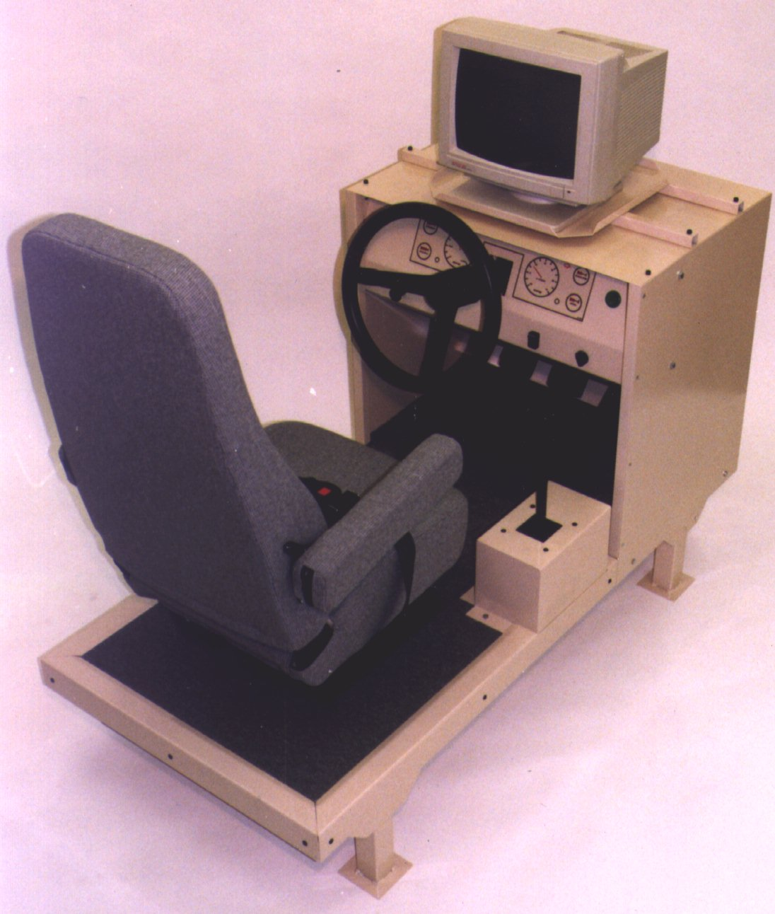
Simulated Car Cab Unit ………………………US $ 13,300
Replaces the modular steering, brake, and throttle units provided with STISIM Drive systems with an integrated simulated car cab unit and seat with standard full-size driving controls.
A manual transmission or automatic transmission selector could also be incorporated in this unit at additional cost.

Manual Transmission …………………………………………. US $5,600
(available with Models 300, 400, 500, and 500W only)

Includes a clutch pedal incorporated in the modular pedal unit and a six - speed manual transmission (5 Forward + Reverse) in a separate modular unit. Additional parameter files are provided for adjusting transmission parameters.

Additional Input-Output Interface Card ……………………… US $1,470

Provides additional digital and analog output channels and digital input channels for interfacing the simulation with other devices and equipment. Allows analog and digital communication between the simulation and external equipment through specific STISIM Drive scenario definition language (SDL) events. All models except for the Model 100 include some digital input-output capability -- this additional card could be used to enhance or add this capability in all STISIM Drive Models.

Other Options Include:

- Projection systems and larger monitors for the driving displays
- Printer
- Special driving control interfaces
- Customized driving scenario development
- Interface with other PC-based cognitive and psychomotor tests
- Consulting services on driver behavior assessment and measurement

STISIM, STISIM Drive, and VDANL-Drive are trademarks of Systems Technology, Inc. All other products and company names are trademarks or registered trademarks of their respective companies.
…’
‘…

European pricelist

STISIM Drive™

DRIVING SIMULATOR CONFIGURATIONS AND PRICES

NOVEMBER 2003

Prices in Euro are fob the Netherlands. Prices do not include shipping and handling charges or applicable sales taxes.

Prices are subject to change without notice.

Model 100 - Game Control Interface

(Interactive driving simulator with a single driving display and 45 degree driver field-of-view, commercial game-type driving controls and STISIM Drive™ simulation software)

Complete System ……………………………………………. € 14.800,-

Includes: Pentium® computer and interface cards (sound/game and graphics cards) with simulation software that supports separate driving and operator’s displays (monitors not included), Windows 2000 operating system, game-type driving controls, amplified audio speakers, electronic Software User’s Manual (HTML files) and 10 hours of phone/fax/email support. System will be configured and tested at STI and/or A&A before shipping.

Model 100W - Game Control Interface, Wide Field of View…… € 29.900.-

(Interactive driving simulator with three driving displays and 135-degree driver field-of-view, commercial game-type driving controls and STISIM Drive™ simulation software)

Includes:

Pentium computers¹ and interface cards (sound/game, graphics) with simulation software that supports three driving displays and an operator’s display (monitors not included), Windows 2000 operating systems, game-type driving controls, amplified audio speakers, electronic Software User’s Manual (HTML files), and 10 hours of phone/fax/email support. System will be configured and tested at STI and/or A&A before shipping.

Model 200 - Analog Control Interface with Spring Centered Steering …… € 22.000,-

(Interactive driving simulator with a single driving display and 45 degree driver field-of-view, robust full-size driving controls with analog sensors, and STISIM Drive simulation software)

Includes: Pentium computer¹ and interface cards (sound/game, graphics, and analog control interface cards) with simulation software that supports separate driving and operator’s displays (monitors not included), Windows 2000 operating system, modular steering unit with a spring centered full-size steering wheel, modular accelerator and brake pedal unit, robust analog control input sensors, audio speakers, electronic Software User’s Manual (HTML files) and 10 hours of phone/fax/email support. System will be configured and tested at STI and/or A&A before shipping.

Model 300 - Digital Control Interface with Active Steering ……………. 36.000,-

(Interactive driving simulator with a single driving display and 45 degree driver field-of-view, robust full-size driving controls with high-resolution digital sensors and speed-sensitive steering feel, and STISIM Drive simulation software)

Includes: Pentium computer¹ and interface cards (sound/game, graphics, and digital control interface cards) with simulation software that supports separate driving and operator’s displays (monitors not included), Windows 2000 operating system, modular steering unit with speed-sensitive steering feel provided by a computer controlled torque motor through a full-size steering wheel, modular accelerator and brake pedal unit, high-resolution digital-optical control input sensors, audio speakers, electronic Software User’s Manual (HTML files) and 10 hours of phone/fax/email support. System will be configured and tested at STI and/or A&A before shipping.

Model 400 - Wide Field-of-View System with Active Steering …………. € 55.800,-

(Interactive driving simulator with three driving displays and 135 degree driver field-of-view, robust full-size driving controls with high-resolution digital sensors and speed-sensitive steering feel, and STISIM Drive simulation software)

Includes: Pentium computers¹ and interface cards (sound/game, graphics, and digital control interface cards) with simulation software that supports three driving displays and an operator’s display (monitors not included), Windows 2000 operating systems, modular steering unit with speed-sensitive steering feel provided by a computer controlled torque motor through a full-size steering wheel, modular accelerator and brake pedal unit, audio speakers, electronic Software User’s Manual (HTML files) and 10 hours of phone/fax/email support. System will be configured and tested at STI and/or A&A before shipping. Requires on-site installation by STI or A&A (cost not included in price).

Model 500 - Comprehensive Vehicle Dynamics Model with Active Steering… € 48.000,-

(Interactive driving simulator with a single driving display and 45 degree driver field-of-view, robust full-size driving controls with high-resolution digital sensors and speed-sensitive steering feel, and STISIM Drive simulation software with the VDANL Drive™ comprehensive non-linear vehicle and tire dynamics model)

Includes: Pentium computers¹ and interface cards (sound/game, graphics, and digital control interface cards) with simulation software that supports separate driving and operator’s displays (monitors not included), Windows 2000 operating systems, modular steering unit with speed-sensitive steering feel provided by a computer controlled torque motor through a full-size steering wheel, modular accelerator and brake pedal unit, audio speakers, electronic Software User’s Manual (HTML files) and 10 hours of phone/fax/email support. System will be configured and tested at STI and/or A&A before shipping. Requires on-site installation by STI or A&A (cost not included in price).

Model 500W - Wide Field-of-View System with Comprehensive Vehicle Dynamics
Model and Active Steering …………. € 71.500,-

(Interactive driving simulator with three driving displays and 135 degree driver field-of-view, robust full-size driving controls with high-resolution digital sensors and speed-sensitive steering feel, and STISIM Drive simulation software with the VDANL Drive™ comprehensive non-linear vehicle and tire dynamics model)

Includes: Pentium computers¹ and interface cards (sound/game, graphics, and digital control interface cards) with simulation software that supports three driving displays and an operator’s display (monitors not included), Windows 2000 operating systems, modular steering unit with speed-sensitive steering feel provided by a computer controlled torque motor through a full-size steering wheel, modular accelerator and brake pedal unit, audio speakers, electronic Software User’s Manual (HTML files) and 10 hours of phone/fax/email support. System will be configured and tested at STI and/or A&A before shipping. Requires on-site installation by STI or A&A (cost not included in price).

Options

The following options are available with all STISIM Drive Models unless otherwise stated.

STISIM Drive Open Module ………………………………. € 13.800,-

The STISIM Drive Open Module allows the user to incorporate custom software modules in the simulation. Example applications include: incorporation of user-developed events in the scenario definition language (SDL), custom displays and audio cues for warning devices, specialized data measurement and recording functions, and interfaces with external hardware. This option permits the user to write and compile source code using Visual Basic 6.0 that can interact with STISIM Drive through the Windows Command Object Model (COM) interface. Example Open Module routines are provided.

VDANL Open Module ……………………………………….. € 11.400,-
(Available with Model 500 and 500W only)

The VDANL Open Module allows the user to incorporate custom software modules in the advanced vehicle dynamics model, VDANL Drive, provided with the Model 500 and 500W. Example applications include: the incorporation of user-developed driver and automatic steering control laws, and control strategies for traction control, active suspensions, and other advanced vehicle control systems including hardware-in-the-loop systems. This option permits the user to write and compile source code using Visual Basic 6.0 that can interact with VDANL Drive through the Windows Command Object Model (COM) interface. Example Open Module routines are provided.

Simulated Car Cab Unit …………………………………….. € 12.800,-
Replaces the modular steering, brake, and throttle units provided with STISIM Drive systems with an integrated simulated car cab unit and seat with standard full-size driving controls.
A manual transmission or automatic transmission selector could also be incorporated in this unit at additional cost.

Manual Transmission …………………………………………. € 5.300,-
(available with Models 300, 400, 500, and 500W only)

Includes a clutch pedal incorporated in the modular pedal unit and a six - speed manual transmission (5 Forward + Reverse) in a separate modular unit. Additional parameter files are provided for adjusting transmission parameters.

Additional Input-Output Interface Card ……………………… € 1.400,-
Provides additional digital and analog output channels and digital input channels for interfacing the simulation with other devices and equipment. Allows analog and digital communication between the simulation and external equipment through specific STISIM Drive scenario definition language (SDL) events. All models except for the Model 100 include some digital input-output capability -- this additional card could be used to enhance or add this capability in all STISIM Drive Models.

Other Options Include:

- Projection systems and larger monitors for the driving displays
- Printer
- Special driving control interfaces
- Customized driving scenario development
- Interface with other PC-based cognitive and psychomotor tests
- Consulting services on driver behavior assessment and measurement

STISIM, STISIM Drive, and VDANL-Drive are trademarks of Systems Technology, Inc. All other products and company names are trademarks or registered trademarks of their respective companies.
…’

AutoSim As. Driving Research Simulator
The general description of this driving simulator, the different configurations available from AutoSim As. and the listed prices as of June 2002 and later, are quoted below. The complete series of proposals can be found in the appendix of this report.

‘…

The most flexible, and cost effective driving research simulator on the market

Whether your business is vehicle development, or general scientific vehicle related research, your human factor studies need a configurable and flexible arena for the experiments. Such an arena must be able to reproduce the driving as close to reality as possible, and at the same time allow for accurate measurements on all important parameters. It should also be easy to interface research equipment to, and to influence certain parameters on during the experiment.
The AutoSim Driving Research Simulator meets all these requirements. The software for this advanced driving research simulator, with the brand name “SCANeR II”, has been in use and under continuous development for the last 10 years. It started with Renault Research Departments work under the EU-project PROMETHEUS, then continued through the Norwegian project AUTOSIM, and later the EU-projects TRaCS, CARDS and SHE.

Advanced users pushing the quality and functionality
SCANeR II is the only commercially available research simulator software. Renault is operating two simulators based on this software, TRL in England is operating one, while AutoSim has delivered one multi vehicle research simulator to SINTEF in Trondheim, Norway, one car research simulator to Fraunhofer Gesellshaft in Stuttgart, Germany, and one car research simulator to University of Minnesota. A SCANeR user group is pushing the technology level even harder, and has become an arena for exchange of knowledge and information among the members, and a common communication channel with the software vendor, OKTAL, for further improvement of the product.

Advanced API for Research Data
In all research application you are dependent on accurate measurements of different aspects of the drivers behaviour, or to communicate with the driver in different ways.
Through a set of user-configurable communication channels, the Data Communication API allows the user to monitor whatever part of the simulation he finds interesting for his research project, while sending his own data to the scenario process, thus enabling him to let external data affect the simulation. As many as 500 communication channels are available.

The scenario process is user programmable, and a set of scenario functions gives you access to the simulation data, which you may then forward to your application through the communication channels.

Powerful Scenario Development Tool
The scenario development tool, MICE, provides you with the functionality to develop very complex scenarios with up to 100 vehicles, pedestrians, and other obstacles. The vehicles are “intelligent” and will act like normal vehicles in the traffic.

Flexible Hardware Configurations
Thanks to experience from earlier deliveries, AutoSim is able to provide a tailor made, turn key simulator solution.
You may have a choice of:
- The number of visual channels or field of view
- The type of front and rear displays (front lighted, back lighted, LED, etc.)
- Resolution and image quality
- Different motion systems (car body vibration, seat vibration, 4-axes electric low frequency motion)
- Different types of cars (Renault Megan Scenic, Renault Magnum, Toyota Yaris, and Saturn are standard)
- Additional displays in the cockpit.
- Programmable servo actions on the accelerator and the steering

Highly affordable
Driving Research Simulators are no longer several million dollar projects. Thanks to standard mass produced components and sub systems, standard software, and skilful and experienced engineers for cabin adaptation and system integration, AutoSim may have a great surprise for your instrument budget.

Price

The prices are given in NOK, (exchange rate at 25.06.02 of: 1 EURO = NOK 7,40).

The prices are FOB Tromsø. University of Jyväskilä will be responsible for custom and other taxes in Germany.

AutoSim will arrange for truck transport and insurance Tromsø – Jyväskilä at the expense of University of Jyväskilä.
The prices include installation in Jyväskylë. Travel and accommodation for one person from AutoSim AS will be at the expense of University of Jyväskilä.

…’

The different configurations available from AutoSim As. and the listed prices as of September 2003 are shown below.

‘…
Prices
All prices are quoted in EURO
- All prices include delivery to University of Jyväskylä location.
- The prices for options should be considered as budgetary prices as options may have different content depending upon University of Jyväskylä requirements and may require different installation
- Hourly rate for an AutoSim engineer is € 110.

Payment Terms
- 50 % of total order at the time of AutoSim’s acceptance of University of Jyväskylä Purchase Order
- 40 % of total order at time of delivery
- 10 % at the time of acceptance by University of Jyväskylä

Delivery Time
1 month after receipt of written Purchase Order from University of Jyväskylä for the entry system (AS 100). Delivery time for other modules will depend on the specific delivery, and will be quoted for each order received.

Installation and Training
AutoSim makes the installation and two days of training for a fixed cost of € 2 700.

Acceptance
University of Jyväskylä will send AutoSim a written acceptance upon successful completion of the installation and the execution of AutoSim’s standard Acceptance Test.

Warranty
6 months from time of Acceptance and includes full support with labor, AutoSim software, and hardware parts.

Maintenance
University of Jyväskylä may purchase yearly Maintenance. A Maintenance contract comes with different options, from basic new version software replacements up to full coverage of software and hardware.
…’

AutoSim As. General Simulation Software
The proposal for the newly developed simulation software environment provided by AutoSim As. was made in April 2004. The full proposal documents can be found in the appendix of this report.

‘…
General Simulator Software

The simulator contains version 1.0 of SimWorld, AutoSim simulator software. This new generation software is developed by use of state of the art software tools and technology, and utilizes all new functionality in the new hardware on the market.
The software consists of following modules:

SimWorld Simulator Software Suite
SW 500 | SimPL RT for one CPU
SW 510 | SimWorld Visual, one channel, incl. basic features
 | Option 1, Medium features
 | Option 2, Advanced features
 | Option 3, Stereo 3D
SW 520 | Autonomous Traffic
SW 530 | Interactive vehicle, Keyboard
SW 540 | Interactive vehicle, Joystick type steering wheel
SW 550 | Interactive vehicle, Real car cockpit
SW 560 | SimWorld Sound
SW 570 | SimWorld Control
 | Scenario Building Tools

Complete systems, AS 1200 to AS 1400 are using the SW 550 Interactive vehicle, Real Cockpit, while AS 1000 may use either SW 530 or SW 540.
SW 500 is required if the customer wants to develop and interface own modules.

Visual Database
There is a complete set of new visual databases, developed on the basis of new graphic technology. Taking advantages of the very latest functionality and capacity in computer graphic boards of today, and prepared for coming functionality.

SimWorld Visual Database Products
SW 600 | SimWorld Visual Databases complete incl. Vehicle Models
SW 610 | Simton City
SW 620 | Highway/ Country
SW 630 | Suburban
SW 640 | Village
SW 650 | Mountain
SW 660 | Vehicle visual & technical models

The different modules can easily be linked together

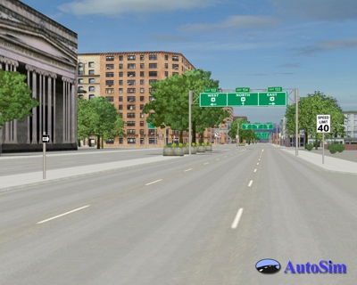

Graphic format: Open GL
Database format: Open Scene Graph (OSG) or Flight (FLT)
Road surface: Asphalt, snow, concrete, cobblestone. By the dynamic model you are able to change the predefined road friction to any value between 0 and 1.

Customer specified visual databases can also be delivered at extra cost.
…’

The price list for this general simulator software is shown in the table below.

‘…

SimWorld Software price list March 01, 2004
Product # | SimWorld Simulator Software Suite | NOK | USD | EURO
SW 500 | SimPL RT for one CPU | 10 200 | 1 569 | 1 200
SW 510 | SimWorld Visual, one channel, incl. basic features | 29 750 | 4 577 | 3 500
 | Option 1, Medium features | 8 500 | 1 308 | 1 000
 | Option 2, Advanced features | 8 500 | 1 308 | 1 000
 | Option 3, Stereo 3D | 12 750 | 1 962 | 1 500
SW 520 | Automomous Traffic | 93 500 | 14 385 | 11 000
SW 530 | Interactive vehicle, Keyboard | 17 000 | 2 615 | 2 000
SW 540 | Interactive vehicle, Joystick type steering wheel | 34 000 | 5 231 | 4 000
SW 550 | Interactive vehicle, Real car cockpit | 85 000 | 13 077 | 10 000
SW 560 | SimWorld Sound | 21 250 | 3 269 | 2 500
SW 570 | SimWorld Control | 34 000 | 5 231 | 4 000
 | Scenario Building Tools | Incl. | Incl. | Incl.
Product # | SimWorld Visual Database Products | NOK | USD | EURO
SW 600 | SimWorld Visual Databases complete incl. Vehicle Models | 225 250 | 34 654 | 26 500
SW 610 | Simton City | 59 500 | 9 154 | 7 000
SW 620 | Highway/ Country | 42 500 | 6 538 | 5 000
SW 630 | Suburban | 42 500 | 6 538 | 5 000
SW 640 | Village | 42 500 | 6 538 | 5 000
SW 650 | Mountain | 42 500 | 6 538 | 5 000
SW 660 | Vehicle visual & technical models | 34 000 | 5 231 | 4 000

OKTAL SCANeR II driving simulator
The general description of this driving simulator, the different configurations available from OKTAL and the listed prices as of November 2003, are quoted below. The complete series of proposal and other information can be found in the appendix of this report.

‘…

SCANeR II
- Human factors for road safety
- Vehicle systems ergonomics for driver safety and impact evaluation
- Vehicle behaviour and architecture
- Perception (navigation, orientation)
- Basic and advanced driver training
- Road infrastructure (crossings, horizontal and vertical signs)

The experience that the Technical Centre for Simulation of Renault’s Vehicle Engineering Development has gathered through its participation in European projects such as Prometheus, TRaCS and CARDS has been the base for the development of the SCANeR©II comprehensive driving simulation software package.
SCANeR©II is a set of application software allowing the user to build either a light or heavy vehicle simulation.
SCANeR©II proposes simulation tools, from database creation to real-time interactive simulation, to replay and post-processing.
Application areas include vehicle and road traffic research and development as well as driver training.

Main Features
- Traffic set up and intelligent vehicles behaviour,
- Accurate vehicle dynamics (car or truck),
- Motion platform simulation strategy,
- Surrounding environment and virtual driving station,
- Accurate night time rendering,
- Easy scenario creation through an interactive graphical interface,
- Weather condition control.

User Oriented
- The user can add new view points, additional driving stations and intelligent traffic,
- The user invests only in the modules he/she needs for his/her application,
- SCANeR©II is scalable according to available computational power,
- It’s easy to interface professional software (Rapid, Lab view, VAPS…),
- SCANeR©II offers a C++ API for interfacing user’s proprietary modules.

Modular Software
- Distributed architecture,
- Ethernet based communication back-bone,
- Multi-platform (WindowsTM NT/2000, Irix®, Linux®),
- Centralised user-friendly supervising application.

Adaptation to available hardware and simulation objectives
- SCANeR©II is scalable according to the driving station chosen by the user,
- Dynamic or static simulator,
- Real or virtual cockpit,
- SCANeR©II offers an API for user’s specific hardware.

User Group
- Free registration included in maintenance contract,
- Services dedicated to users (private access to the web site, users’ meetings…),
…’

‘…
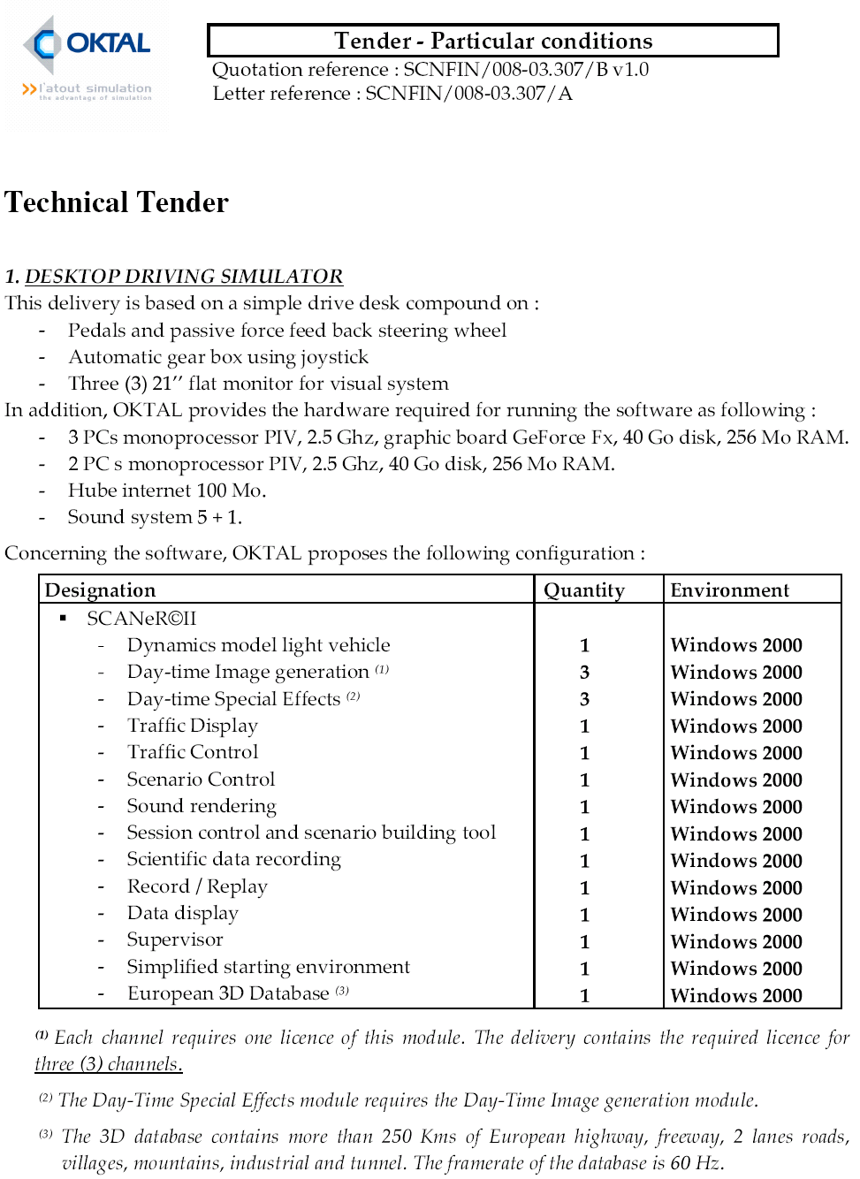

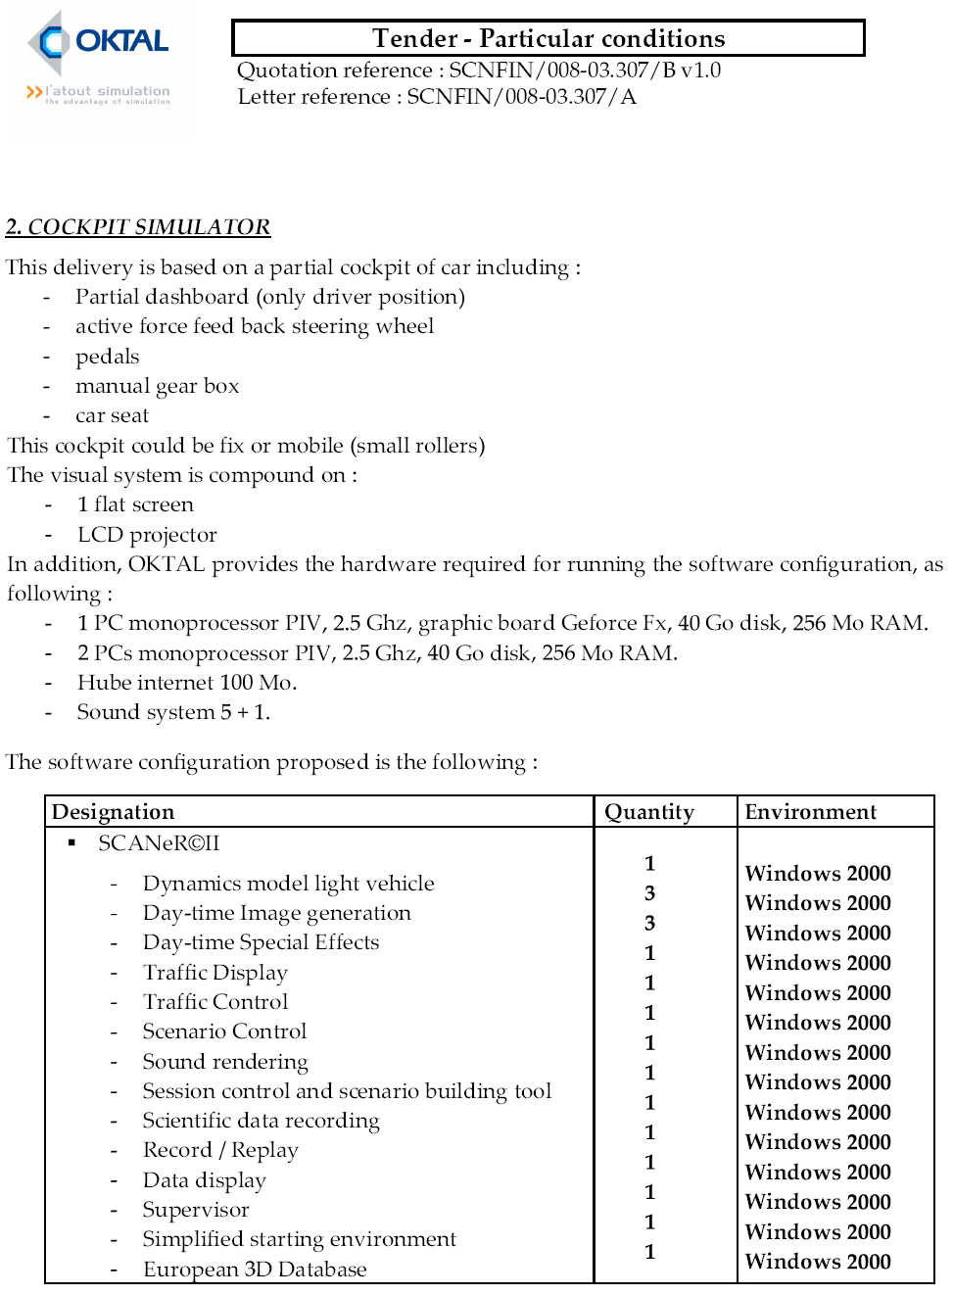
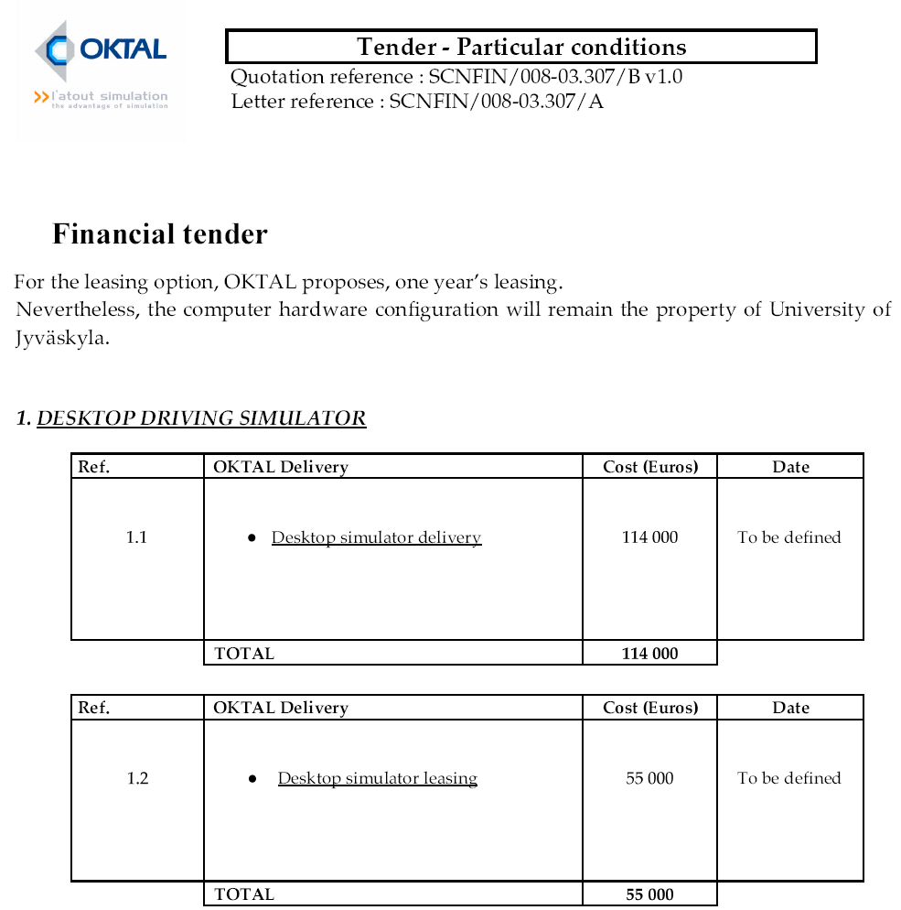
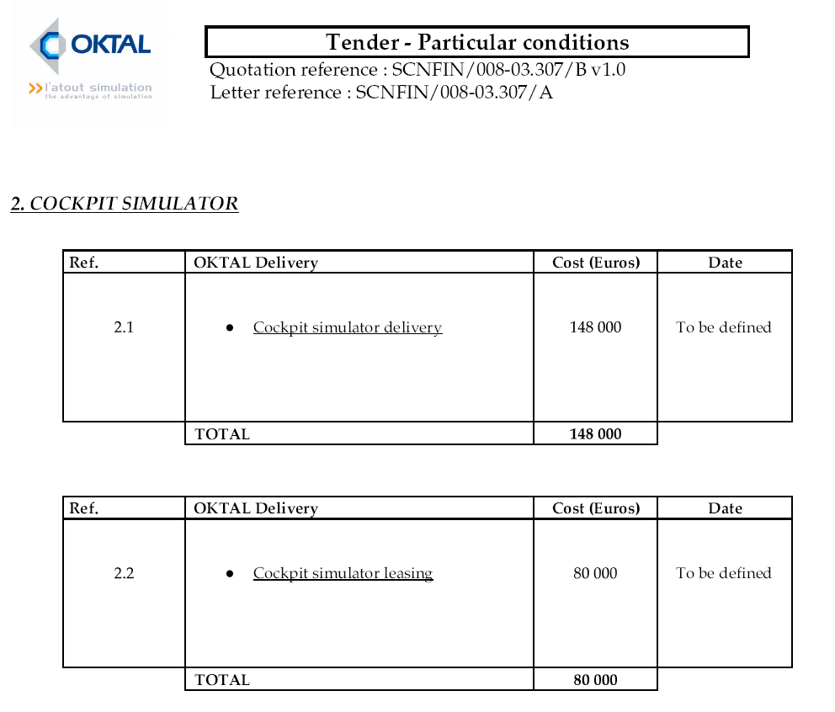
…’

GlobalSim Inc. DriveSafety Research Simulator
The description of this driving simulator and the different configurations available from GlobalSim and the listed prices as of 17.12.2003 are quoted below.

‘…

The DriveSafety Research Simulator (DRS) is a fully integrated, high performance,
driving simulation system designed for use in ground vehicle research and training
applications. The DriveSafety Research Simulator product line ranges from part-task
desktop simulators to full motion multi-channel systems with real vehicle cabs and
wraparound displays. Current installations range from research institutions to automotive
industry companies.

Whether your driving scenario needs to include basic autonomous traffic or custom defined
scripted vehicle actions and reactions, the DriveSafety Research Simulator (DRS) excels at
both. Depending on the application needs, custom databases and scenarios can be developed
by GlobalSim, or created using the optional HyperDrive Authoring Suite™.

GlobalSim DriveSafety simulator

I have listed below pricing for several different simulator options that
DriveSafety offers. Please note: all of the simulators use HyperDrive &
Vection, the only difference is the level of fidelity between each
vehicle simulator. I have also attached several digital files for you to
gain a better understanding of our products and those researchers who
are successfully using DriveSafety products.

Configuration #1: Desktop Single Screen

(1) HyperDrive License

(1) Vection License (Host & Single Channel Computer)

(1) Game Wheel & Pedals

(1) Hardware & Software Maintenance Contract

(1) 20” LCD Panel High Refresh

Total: $83,000 (US) / 3 Screen Configuration Total $101,000 (US)

Not Included: Desk / HyperDrive Authoring PC & Monitor for Desktop Sim.

Shipping is FOB Origin & HyperDrive On-Site 2-Day Training is $2,400 not
including travel expenses.

Configuration #2: Advanced Desktop Single Screen

(1) HyperDrive License

(1) Vection License (Host & Single Channel Computer)

(1) Control Force Loaded Steering Wheel & Instruments

(1) Hardware & Software Maintenance Contract

(1) 20” LCD Panel

Total: $104,000 (US) / 3 Screen Configurations Total $121,000 (US)

Not Included: Desk / HyperDrive Authoring PC & Monitor for Advanced
Desktop Sim.

Shipping is FOB Origin & HyperDrive On-Site 2-Day Training is $2,400
(US) not including travel expenses

Configuration #3: 1 Channel Mini Cab Vehicle Sim (This configuration in
a 5 Channel setup is called the 500C)

(1) HyperDrive License

(1) Vection License (Host & Single Channel Computer)

(1) Complete Mini Vehicle Cab and 41” Monitor

(1) Hardware & Software Maintenance Contract

Total: $125,000 (US) 3 Screen Configurations Total $161,000 (US) 5
Screen Configurations Total $ 192,000 (US)

Not Included: HyperDrive Authoring PC.

Shipping is FOB Origin & HyperDrive On-Site 2-Day Training is $2,400
(US) not including travel expenses

Configuration #4: 5 Screen Full Cab Vehicle Sim

(1) HyperDrive License

(1) Vection License (Host & Five Channel Computer Rack)

(1) Complete 5 Channel Projector and Screen Configuration

(1) Hardware & Software Maintenance Contract

Total: $227,000 (US)

Not Included: HyperDrive Authoring PC.

Shipping is FOB Origin & HyperDrive On-Site 2-Day Training is $2,400
(US) not including travel expenses

Please let me know if you have any questions or suggestions. We would be
very excited to work with your team of researchers.

Best regards,

Clayne A. Woodbury

Director of Research Sales

DriveSafety

801.554.5334

801.818.6768

<http://www.drivesafety.com/> www.drivesafety.com

…’

GSC AUTOSIM Driving Simulator for driving schools
‘…
Our driving simulators (AUTOSIM, 3-channel car simulator and bus simulator) are serial products specially designed for learning how to drive.

1 AUTOSIM

Right now there are more than 400 units of AUTOSIM working in driving schools in Spain, Portugal, Norway, Italy, Holland, Mexico, Canada. Also the Jordan Security Forces, the Portuguesse and Spanish armies and the MARA teknology university use this product.
In February it will be ready the first unit of AUTOSIM in Finish language and we are going to start the distribution of our product in the driving schools of your country. We are going to distribute our simulator in Finland through a local distributor so there will be no problem for technical support on any of our products.

AUTOSIM can be used as a single unit or if you have some units in a room you can netconnect them all to an instructor position so one person can check in one monitor what everybody is doing and you can get statistical data about their perfomance.
(Please check the document atached for more information AUTOSIM.pdf).

Price for AUTOSIM is around 12.000 Euros.

2 3-Channel car simulator

This simulator is already being used in Spain for some big companies interested in teaching experienced drivers in safe driving .
This simulator has some exercices especially designed to train people to avoid risks and accidents while driving.
It use three projectors and three screens so the driver has a wider vision angle (150º) while driving.
Price for this simulator is 36.000 Euros.

3 BUS SIMULATOR

This product is actually being used for the Madrid Public transportation company and for a training center for Bus drivers in the Spanish city of Mieres.
This simulator is connected to an instructor position from where a person can design traffic and weather conditions and some other specifications of the road.
Price of this simulator depends on the concrete specifications of the customer and it goes from 180.000-600.000 Euros.
Please check the document atached for more information Bus simulator.pdf.

The specifications you are requesting for your simulator are:
a.. Posibility to design your own scenaries (road, weather condition, people, other cars, etc)
b.. Posibility to collect data about driver perfomance and car behaviour in the road
Maybe the simulator wich will meet your demands would be the AUTOSIM or the 3-channel sim. To fix exactly your specifications maybe it could be necesary to do some changes. . Most of the teknology required is developed so we could do that.

The only thing we need to make a bid for you on this simulator is to have a detailed description on the specification requested. For example.
Do you need specially designed exercices (emergency braking, slading road, etc) or a big driving scenary where you can check driver´s reactions?
Do you need urban and inter urban scenaries?
What are the specific data you want to collect from driver´s performance?
What are the road and driving conditions you want to be able to change?

Anyway if you want to check personally if our simulator fix your demands you can have a personal demonstration on our offices in Madrid. You will also have the chance to see the AUTOSIM in Finish language in your country by February.

In order to cooperations between your university and our company I would like to advice that we are an active company with a team of software developers ready to meet any customer demand and that actually we are focusing our company to develope simulators for proffesional training (crane simulator, forklift simulator, etc) to help companies to reduce the number of accidents at work.

Please if you need more information do not hesitate to contact me by mail or in my cell phone (0034) 626613307.

Best regards

Bruno Torresano Rodriguez
International sales manager
…’

Preferred driving simulator system: Requirements

Conceptual description

The initial purposes of the Truck Driving Simulator Assessment and Monitoring System (TDSAMS) are the assessment of professional truck drivers’ abilities and skills, and the monitoring and assessment of alertness states of professional truck drivers and non-professional drivers. The conditions on which the drivers will perform the simulated driving task must be constructed so that these are from hazardous to very hazardous. One important part of the assessment and research system is to evaluate the abilities and skills of the truck drivers in conditions that are more difficult than the ones found in an average workday. It is not likely that average driving situations and conditions can offer good possibilities to establish differences between poor and good drivers. Similarly, it is less likely to unfold differences between experimental manipulations in average driving situations than in more hazardous or demanding ones.

Driver skills

Training and assessment programmes for drivers focus on car control and road positioning skills. This is, perceptual-motor skills such as tracking, manoeuvring, visual surveillance, and visual search. Other perceptual-cognitive skills such as hazard perception, situational awareness, action planning, decision making, understanding driving goals and contexts, self-evaluation and knowledge, and understanding driving motives, are not so relevant in driver training and almost inexistent in driver assessment protocols. The driving incident scenarios described below provide the conditions to assess and monitor drivers’ performance in conditions demanding the demonstration of both perceptual-motor and perceptual-cognitive skills.

Manned vehicle
The TDSAMS is firstly conceived to simulate a generic truck. The truck can be a 3-axel single-unit truck or a trailer (i.e., a single-unit truck pulling a trailer). These two types of truck are the initially selected candidates for the TDSAMS because they are the most commonly used in Finland for long-distance transportation of goods and materials. Therefore, they can be considered highly representative. The choice for any of these two possibilities depends on the possibilities to implement the dynamic model of each of these alternatives. One advantage of implementing a single-unit truck is that the dynamic model can be used for simulating a bus with few adjustments in the parameters of the model. One advantage of implementing a trailer is that this would allow for assessment of more complex perceptual-motor skills because manoeuvres on this type of vehicle are somewhat more complex than on a single-unit truck.

Road environment
The road and the environment surrounding it can be specified in several possible ways. In the follow sections two alternatives are described from which the virtual visual environment can be modelled. The final visual appearance of the virtual world in which the simulated driving takes place will be either of these two alternatives or a mixture of features from both of them. This aspect will be decided after the basic tools to start the development of the TDSAMS are provided to the developer team in the Virtual Reality Laboratory (Agora Center).

Actual road segments selected from crash statistics
The road segments of the Finnish road network which accumulate greater frequency of traffic accidents (fatal and non-fatal) will be selected from crash statistics. Once the road segments with greater frequency of accidents are identified, the road and the surrounding environment will be modelled. These will thus constitute the visual environment in which the drivers will be assessed and monitored. The selection of these road segments is in progress at the present moment. The rationale behind this approach is that the simulated driving should be from hazardous to very hazardous to the drivers. Hence, those more hazardous road segments are more likely to impose higher demands on the drivers than other road segments from which no information about their hazard level is known.

Examples of road course
As an example of the road through which the drivers will perform the simulated driving task will be modelled, to a certain extent, according to the course of the road number 4 from Jyväskylä to Lahti. In a second example the road can be modelled to resemble the course starting in Jyväskylä and ending in Lahti following the road number 9 until its junction with the road number 24 at Jämsä, and continuing until Lahti through this road. Another alternative road course starts also in Jyväskylä and ends in Lahti, but follows different road segments. The first one starts in Jyväskylä and follows the road number 9 until its junction with the road number 610. The second segment follows the road number 610 until its junction with the road number 612 at Rantakylä. The third segment follows the road number 612 until its junction with the road number 314 at Sysmä. The fourth segment follows the road number 314 until its junction with the road number 24 at Asikkala. The last segment follows the road number 24 until Lahti. The road information has been obtained from the Tiehallinto web service http://www.tiehallinto.fi/kartta/kartta.htm. The road itineraries described can be altered to accommodate the assessment and research needs. This means that the road course chosen as starting point for the TDSAMS does not need to resemble the exact characteristics of the actual roads.

The road will be modelled in accordance with the conditions of the road, i.e., two lanes for two directions of travel with shoulders of appropriate measures. The road surface will resemble the actual asphalt roads, including the wheel tracks engraved on the road surface by the transit of heavy traffic. This condition of the road surface is found in many road segments. The road shoulders can be made of asphalt or gravel, or both, i.e., one part of asphalt and the rest of gravel as the one shown below (Road 24, Asikkala). Roadside ditches must also be modelled in close relation to the actual roads. Roadside ditches can differ in shape, depth, and width.

As integrating parts of the road course, intersections, and T-junctions, Y-junctions, roundabouts, bridges, etc. will be modelled to resemble the actual road segments. In this respect, some of these features might be modelled according to the assessment and research needs instead of the actual features of the modelled roads. Some examples of this departure from reality might include, road construction work areas, non-existing intersections, curves with different characteristics from the real ones, e.g., convexity, radius, spiral, and so forth.

Road marks, barriers, post-mounted delineators (roadside reflective sticks), traffic signs, traffic lights, pedestrian passes, traffic islands, light-posts, etc. will be modelled to resemble, to a certain extent, the actual road characteristics but not necessarily as exactly as the ones found in the actual roads.

As an example, if a segment of the road number 24 is modelled, it should resemble the one shown below. See Figure 1.

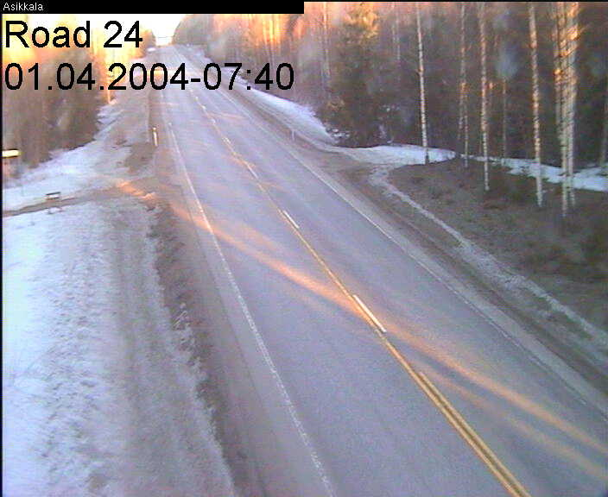

Figure 1. The picture shows a segment of the road number 24 in the Asikkala area at 07:40 in a sunny day. Source: http://www.tiehallinto.fi/alk/frames/kelikamerat-frame.html

Surrounding landscape

The landscape around the road course will look very similar to the actual landscape found in the actual roads. This will include buildings in populated areas, forests, lake areas, other characteristic buildings such as farmhouses and other residential houses along the road, etc.

Daylight conditions

As stated earlier, the simulated driving environment, similarly to other events and conditions will be modelled so that the probability of hazards is increased in comparison to the actual workday diving. Thus, daylight conditions will be simulate to accommodate the periods of the day which are more adverse for driving such as the period before sunset, the sunset, the twilight period after sunset, and the dark night. These periods of the day should affect detrimentally the visual perception of the driver. Therefore, the driving conditions should facilitate more hazardous planned and unplanned driving events during the simulation runs.

Weather phenomena

Similarly to the daylight conditions, the modelling of weather conditions should be done in order to increase the probability of hazardous situations. Hence, segments of the road will be immersed in snowy, rainy, foggy and clear sky conditions of different intensities. Lateral wind gusts of varying intensity will also be introduced in the simulated environment. These will be modelled to push the truck away from the normal course of the road requiring the driver to perform continuous steering adjustments. This phenomenon should increase the difficulty of keeping the truck on the lane. Thus the road tracking behaviour under these weather conditions should serve to differentiate driver categories and their physical and mental states better than optimal weather conditions.

Truck driving incident scenarios

The incident scenarios are defined as a set of conditions and events programmed by the TDSAMS users on the truck driving simulation runs. These are conceived to expose the truck driver to expected and unexpected events, which can happen in actual driving conditions. The incident scenarios described below should elicit adequate and inadequate decisions and manoeuvres on the truck driver so that the hazardous situations encountered are managed in a safe manner. The frequency of these incident scenarios throughout a simulation run will be greater than in actual driving conditions. This condition aims to collect sufficient and useful assessment and monitoring data. Simulating the truck driving conditions in circumstances similar to the actual traffic would not allow the collection of sufficient data or the data would not be useful for discriminating different types of drivers. Also, monitoring the driver states would not be possible if only very infrequent events elicit measurable behaviours.

Perceptible pedestrian along the right-hand side of the road

Difficult to perceive pedestrian along the right-hand side of the road

Perceptible pedestrian along the left-hand side of the road

Difficult to perceive pedestrian along the left-hand side of the road

Pedestrian crosses the road unexpectedly (no pedestrian pass) left to right

Pedestrian crosses the road through the pedestrian pass left to right

Pedestrian crosses the road unexpectedly (no pedestrian pass) right to left

Pedestrian crosses the road through the pedestrian pass right to left

Perceptible bicycler along the right-hand side of the road

Difficult to perceive bicycler along the right-hand side of the road

Perceptible bicycler along the left-hand side of the road

Difficult to perceive bicycler along the left-hand side of the road

Bicycler crosses the road unexpectedly (no bicycle crossing) left to right

Bicycler crosses the road through the bicycle crossing left to right

Bicycler crosses the road unexpectedly (no bicycle crossing) right to left

Bicycler crosses the road through the bicycle crossing right to left

Difficult to perceive moose along the right-hand side of the road (wild animal warning traffic sign)

Perceptible moose along the right-hand side of the road (wild animal warning traffic sign)

Difficult to perceive moose along the left-hand side of the road (wild animal warning traffic sign)

Perceptible moose along the left-hand side of the road (wild animal warning traffic sign)

Difficult to perceive moose crosses the road unexpectedly left to right (wild animal warning traffic sign)

Perceptible moose crosses the road unexpectedly left to right (wild animal warning traffic sign)

Difficult to perceive moose crosses the road unexpectedly right to left (wild animal warning traffic sign)

Perceptible moose crosses the road unexpectedly right to left (wild animal warning traffic sign)

Difficult to perceive moose along the right-hand side of the road (no wild animal warning traffic sign)

Perceptible moose along the right-hand side of the road (no wild animal warning traffic sign)

Difficult to perceive moose along the left-hand side of the road (no wild animal warning traffic sign)

Perceptible moose along the left-hand side of the road (no wild animal warning traffic sign)

Difficult to perceive moose crosses the road unexpectedly left to right (no wild animal warning traffic sign)

Perceptible moose crosses the road unexpectedly left to right (no wild animal warning traffic sign)

Difficult to perceive moose crosses the road unexpectedly right to left (no wild animal warning traffic sign)

Perceptible moose crosses the road unexpectedly right to left (no wild animal warning traffic sign)

A car stopped on the right side makes unexpected U-turn

A car stopped on the left side makes unexpected U-turn

At a T-junction, a car turns right unexpectedly to main road

At a T-junction, a car turns left unexpectedly to main road

At a crossing, a car crosses unexpectedly

At a crossing, a car turns right unexpectedly

At a crossing, a car turns left unexpectedly

At a crossing, a car crosses unexpectedly and stops suddenly on the road

At a crossing, a car turns right unexpectedly and stops suddenly on the road

At a crossing, a car turns left unexpectedly and stops suddenly on the road

At a crossing, a car crosses right to left while the field of view of the manned truck is blocked by another truck turning to the right

At a crossing, a car in the opposite direction turns to its left while another truck in the same direction as the manned one turns to its left, the field of view of both, the manned truck and the car turning to the left is blocked by the second truck (turning to its left)

Suddenly, an excavator on the roadside ditch loads a truck on the right-hand lane (poorly signalled work area)

Suddenly, an excavator on the roadside ditch loads a truck on the left-hand lane (poorly signalled work area)

Same direction car overtakes the manned truck with insufficient safety margins

Opposing direction car overtakes another truck with insufficient safety margins

Same direction truck overtakes the manned truck with insufficient safety margins

Opposing direction truck overtakes another truck with insufficient safety margins

Same direction coach overtakes the manned truck with insufficient safety margins

Opposing direction coach overtakes truck with insufficient safety margins

Sudden traffic stop with many vehicles in front and some vehicles in the opposite direction

On a sudden traffic stop in the opposite direction, a car overtakes the stopped ones without being able to return to its right lane

A curve to the right has slight inner superelevation instead of outer superelevation

A curve to the left has slight inner superelevation instead of outer superelevation

The radius of a curve to the right suddenly decreases more than 5 degrees

The radius of a curve to the left suddenly decreases more than 5 degrees

The driving incident scenarios outlined above will be detailed later. The incident scenarios can be more complex or varied by changing other characteristics of the scenarios, e.g., changing daylight conditions, weather conditions, etc. Therefore, the number of possible changes in the surrounding conditions can multiply the number of incident scenarios. This will reduce the possibility that the truck driver can predict the occurrence of each of these incident scenarios.

Non-driving stimulus presentation

Embedded in the truck driving scenarios there will be presentation of visual stimuli to the truck drivers requiring a response to them. These stimuli will appear in different areas of the viewing screen/s superimposed to the driving environment. Also, presentation of auditory stimuli must be available. These might be presented through loudspeakers or headphones and the source location of the stimuli must be configurable so that sounds can be presented at different locations.

Software functionality

The functions required from the software are defined in general terms to enable the maximum capabilities possible. In this fashion, not only the aims stated earlier can be realised but also others that can be identified in the future.

- Possibility to develop or customise the driving scenarios and the graphical database with the highest realistic appearance possible, scenario refresh rate, image resolution, contrast, brightness, antialiasing, perspective, visual occlusion, motion parallax, etc. If some pre-programmed scenarios are provided with the simulator, this should permit authoring possibilities to adapt the scenarios to the assessment and research needs
  - static graphical database objects with 3D graphics capability (texture, shading)
    - road network development of sufficiently long length, straight segments, curves, intersections, roundabouts, profiles, etc.
    - road types, city, country, motorway, etc.
    - road condition, dry, wet, gravel, slippery, etc.
    - external landscape, e.g., road signs and signals, terrain, trees, buildings
  - dynamic graphical database objects 3D graphics capability
    - weather conditions, wind, fog, rain, snow, etc.
    - surrounding vehicles, cars, trucks, coaches, make, models, colours
    - pedestrians
    - bicyclers
    - wild animals
  - daylight conditions, day light, twilight, sunset, night, sunrise,
  - driving events presented to the driver according to road network distances, locations, elapsed time since the beginning of the simulation run, including other vehicles in the scenario, pedestrians, road signs, animals, tickets resulting from traffic norms violations, etc.
- Realistic truck dynamic model with the possibility to change different parameters of the model, number of axles, number of wheels, grip of the wheels (this should be directly correlated with the characteristics of the road surface), engine power, manual and automatic gearbox, wheel suspension, aerodynamic characteristics, etc.
- Pseudo intelligent/autonomous surrounding traffic model with the capability to determine/program the behaviour of some of the vehicles by the researchers
- Input/output functions to synchronise the simulation with external equipment, e.g., psychophysiological recording equipment, eye tracking, stimulus presentation, etc. The simulator must be capable to receive and to produce triggering from/to external equipment.
- Record, replay, rewind, fast forward, video capabilities to enable the review of the performance of the driver throughout the simulation run by the assessment or research personnel. The point of view of the camera for the IOS and the replay function must be configurable. This is, must also permit reviewing the simulation run from other viewpoints different than the driver’s viewpoint.
- Data recording of car and drivers’ performance measures including means and standard deviations of these parameters
  - vehicle speed
  - steering wheel position, movement and speed
  - throttle pedal position, movement and speed
  - brake pedal position, movement and speed
  - tickets for traffic rule violations (speed limits, traffic signs, traffic lights, road marks, etc.)
  - car heading error with respect to the road
  - lane position
  - lateral position
  - gap acceptance
  - time to collision
  - car following distance
  - time to line crossing
  - time of occurrence and distance of specified simulation events
  - reaction times of the driver to events and/or stimulus presentation
  - other contingent responses of the driver to specified conditions
- Data recording of drivers’ performance by means of the input/output functions of the simulator (see above)
- Summarised presentation of the results and possibly in accord with normalised scales to be defined by the researchers requiring this data

Hardware configuration

This section refers to the hardware interface with the drivers during the simulation research activities (a driver driving on the simulator). The hardware components needed to run the simulation application software are PC computers, video projectors and screens, and driving controls, i.e. steering wheel, throttle and brake pedal as minimum requirements. Clutch pedal and gear lever controls could be added in future stages of the project.

- The simulator has been conceptualised as a fixed base one, at least in the beginning of the project. This is, the elements of the simulator are static in relation to the virtual environment in which the driver’s performance takes place.
- Real truck cockpit was preferred against game-like driver seat and controls. However, given the high costs associated to this subcomponent of the simulator (above € 50 000), and the integration work/cost required, less expensive and less realistic looking controls will be used at this first stage of the implementation of the simulator.
- Realistic force-feedback from the driving controls, such as steering wheel, throttle, brake, clutch, gear lever, etc., similarly to the truck cockpit, has been discarded at this first stage of the implementation for similar reasons.
- Front view video projection of the driving scenarios on wide angle (at least 180º field of view) screens.
- Rear window view video projection/mirrors view.
- Active loud speakers to provide auditory information, such as, engine, road tyre friction, wind, surrounding traffic, etc.
- Instructor/researcher operation station (IOS) from which the instructor/researcher can develop the simulation scenarios, control, and supervise the progress of the simulation runs during the assessment and/or research activities.
- In future stages of this project the fixed base platform could be replaced/upgraded with a motion base platform. Considering the high prices of the motion bases, this option has been discarded at this stage of the project. Depending on the assessment and research needs and the financial availability, this option could be reconsidered in future stages. If this option would be implemented in the future, in addition to the economical considerations for the acquisition of the hardware (motion base platform either hydraulic or electrical), the load and forces generated by the motion platform should be carefully considered in choosing the adequate building for the location of the simulator and possibly additional construction work for the basement of the platform.

Staged Description for the Investment in the WDL DS

Part of the report AgoraCenter/VR-laboratory, Driving Simulator Project AgoraCenter and Neuroarviot, DRAFT version 5, AgoraCenter delivered to Jyväskylä Science Park on 24.02.2004 is provided in this section. Note however, that as the organisation that will finally purchase the software and hardware has changed after this document was issued, it may not be fully applicable—the initially assumed buyer has been Agora Center in the absence of formal statements, recently Jyväskylän Ammattikorkeakoulu has decided to carry out the purchase of these components instead of Agora Center.

Neuroarviot, and Agora Center have two levels of goals in which the schedule and budget for the DS can be better understood. These are in agreement with the mandatory preconditions indicated above, see section 1.1:

1. To have fast access to the driving simulator (DS) system (i.e. buying the hardware and development tools) and the preparation and implementation work needed for a working assessment component to the bought DS system agreed by Neuroarviot, Human Protection, and Agora Center.
Six months, see the detailed budget, are needed for accurate specification of the DS functions and the driving scenarios for the elicitation of the relevant drivers’ behavior, and for implementing these functions and scenarios.

Specification, here, refers to the detailed description of the functions, driving scenarios, and assessment-related processing of the driver’s behaviors the DS will perform. Neuroarviot, and Agora Center will describe, as exhaustively and as precisely as we can, these three main properties for the implementation on the to be build DS which we need for reaching our goals. This means that among others, the description of the driving scenarios on which the professional drivers will perform the driving tasks (road type, e.g., city, country, two-lane, motorway; road surface characteristics, e.g., asphalt, sand, dry, wet, snowy, icy; visibility conditions, e.g., day time, rain, snow, fog, night; road course characteristics, e.g., straight, curve, junctions, crossings, roundabouts; driving events, e.g., traffic lights, pedestrians, wild animals, etc.), the collection and storage of the necessary measures and indications of the driver's behavior while driving including his/her mental state-variation (steering wheel movement, actions on throttle and break pedals, and other instruments, such as monitoring the direction of attention gaze and vigilance some requiring video recording, physiological signals contingent on driving events, reaction times to specified driving events, dual task situations, etc.) will be specified.

The specification process will be performed iteratively and will be agreed/negotiated with Juhani Forsman from Agora Center CAVE laboratory. This iteration is necessary because, some times, the functions specified might require additional explanations to the implementers for them to be able to realize these. Some other times, the functions might be extraordinarily time demanding for implementation within the time schedule proposed in this budget (12 months). For this specification work, interviews with professional driving and driving teaching/assessment experts, review of car accident statistics, behavioral/driver’s state measurement needs and possibilities/techniques as well as definition of critical driving situations and their effective and ecologically valid merging to the scenarios should be performed. These create the basis for the concrete definitions of relevant driving functions, scenarios and assessment features whose accurate documentation is needed for the implementation work of the assessment DS.

2. To test the implementation (6 months) of the DS assessment system which is built on the basis of the programming tools received from the software provider and the specifications given by Neuroarviot, and Agora Center. The results of this system testing provides the necessary DS for the national driving assessment and training centre for professional drivers. Negotiations between Peurunka Rehabilitation Center in Laukaa and Neuroarviot are in progress at the moment (Perunkaan siirtoon tarvitaan varmaan muiden osallisten suostumus, Agoran näkökulmasta ei estettä, jos kehitystyö halutaan jättää tuossa kohti saavutettuun vaiheeseen).

It will be possible to reproduce/duplicate the whole system to the firms, Neuroarviot, who is involved in this action and possibly also for selling to others. This allows a change of the location of the DS for professional assessment and training from the university to other premises, e.g., to Neuroarviot’s premises, when the companies require this.

Additionally, a network of assessment and training centres can be built when the DS functions and driving scenarios needed for the assessment and training of professional drivers can be reproduced/duplicated without being too much affected by an external provider or a high price. The DS system will be owned by the partners. Software licenses might have to be paid to the software provider, i.e., SimPL simulator development platform, if it is needed after full implementation of the DS.

The time schedule is such that if the funds will be provided according to this plan the stages fulfilling the second goal should be ready one year after the funding has been granted and when the whole funding (supposing we can have 80 000 Euros). At this time the assessment DS will be ready for starting the professional driver assessment and training activities and will also be ready for the assessment of any support features implemented in the driving environment of interest to Human Protection. The preceding system testing work (stage 1) can be seen as a piloting stage. Some compensation, apart from this budget, is needed to compensate the substantial investment of time needed from the experts of the firms, Neuroarviot, Human Protection and Oivallin Oy, which are involved in this action. Their own share (to earn the ownership to the results) to the investment should be accepted via the part of their work. The applied funding from Academy and Tekes (via the INBCT project of Agora) to Narciso could partly pay the system testing work he can make together with the firms.

There are three main domains of professional driver assessment and training purposes:
1. assessing professional drivers' skills, professional driver selection, and professional driver’s health related issues, which are interconnected but may require some separate actions
2. training of driving to be prepared and able to survive in exceptionally demanding (at least to the individual, thus including also aged or impaired drivers) driving situations, e.g., training of professional emergency car -ambulance, police- drivers in critical situations.

3. assessing the effects on driving and assessing (the acquisition of) the use of new cockpit technologies, and their effects on driver's physical and mental states or their regulation.

Time Schedule and Detailed Budget for the DS Project

- In the first phase, lasting for 6 months since the funding procurement date, the project proceeds with two tasks in parallel. The first one will be the acquisition process of the driving simulator software and devices needed for minimal development installation, which can also be used for actual testing. The minimal installation will consist of SimPL software, steering devices and computers. Projectors can be excluded from this purchase phase because, for development purposes, the projectors of the Agora Center CAVE laboratory can be used. The other simultaneous task with the purchase process will be the specification process of the functional requirements of the simulator software to be programmed in the second phase.

BUDGET (6 months):

- SW 510 SimWorld Visual: € 3 500 + ALV
- SW 540 Steering control software: € 5 000 + ALV
- 2 SW 500 SimPL licenses: € 2 400 + ALV
- 3 PC computers (1 control station,
1 video channel, 1 independent for development): € 4 500 + ALV
- Steering controls hardware: € 1 000 + ALV
- I/O card (interface for external
controls and equipment): € 1 000 + ALV
- Network Switch full duplex
(the computers must be networked): € 400 + ALV
- Specification and development: € 8 400 + ALV

- Maintenance: The maintenance cost for this period is included in the
specification and SW implementation if the users participate in the user
training sessions.
- Rent for location of the DS: Not needed during this period

Note: One SW 500 SimPL license is needed for each of the computers required by the DS. One extra computer is added to the visual channel and control station computers, because it is necessary to have separate computers for development and for production use. Production use computers need to have stable software environment. This cannot always be guaranteed for development ones. Also the usage of DS will increase as time goes by, which will in turn decrease the possibilities for development if it is done with the control station. For specification and development work the cost is 3 work months and it includes all mandatory additional costs. The time schedule available for the documentation of the specifications the end user want the whole functional system to follow should be clearly mentioned with the notes concerning the effects of any delays in this work.

- The second phase starts at the beginning of October 2004 or may be earlier if the specifications for the functional requirements would be ready and the software already purchased. A preliminary estimate would be such that some parts of the simulator software would be ready at the beginning of December 2004, which could enable starting of actual testing with some restricted set of options. Without knowing the actual functional requirements, it is estimated that full functionality could be achieved at the end of the 12-month period.

BUDGET (6 months):

- 3 SW 500 SimPL licenses: € 3 600 + ALV
- 3 PC computers (2 additional front video channels
180 degrees field of view, 1 rear video channel): € 4 500 + ALV
- 4 LCD Projectors (3 front and 1 rear video
channels) and 4 projection screens: € 16 000 + ALV
- Specification and software development work: € 25 200 + ALV
- Maintenance: The maintenance cost for this period is included in the
specification and SW development if the users participate in the user training
sessions.
- Maintenance after delivery of the DS: The users (companies) will be charged
on an hourly-based scheme for the required maintenance work.
- Rent for location of the DS (6 months): € 2 851 + ALV

Note: Specification and development work for 6 months and it includes all mandatory additional costs.

Total budget (12 months): € 78 351 + ALV

The development and implementation of the functions and scenarios of the DS will be performed by 4-6 information technology students trained in programming 3-D environments. They are trained and supervised by the chief of the Agora virtual reality laboratory, Juhani Forsman. Juhani Forsman’s salary is paid by the University of Jyväskylä, Agora Center. Also other people paid by the University have invested time to this project. Thus, the university has invested and will invest substantial resources to this project if Agora board will accept our proposal.

Evaluation of the investment: preferred simulator
The evaluation of the investment in the TDSAMS is made on the basis of the state of the project at the present moment.

Benefits

The TDSAMS will provide benefits directly through the development of new professional assessment services by Neuroarviot. The TDSAMS will also contribute to the realisation of the project Psychophysiological and Behavioural Monitoring of Drivers’ Alertness in a Driving Simulator lead by Narciso Gonzalez Vega in collaboration with Heikki Lyytinen and Jukka Kaartinen (Agora Center and Department of Psychology). Funding for the development of this project has been granted by the Academy of Finland.

The solution adopted, i.e., a goal oriented truck driving simulator assessment and monitoring prototype, to be developed based on the general simulation software developed by AutoSim As. and some system development work to be performed by the Agora virtual reality personnel lead by Juhani Forsman. This is the only option, among those offers supplied by the driving simulator providers reported above, see section 2.2, that fulfils the preconditions established by Neuroarviot and Agora Center as follows:

- the TDSAMS shall be an integrated system,
- auomatization of the assessment, monitoring and training functions shall be available through the TDSAMS,
- the software source code of the TDSAMS shall be open,
- the ownership of the TDSAMS shall remain within the partners group. This requirement still needs to be defined by Jyväskylän Ammattikorkeakoulu, Neuroarviot and Agora Center. Nevertheless the solution adopted should not pose limits to this requirement,
- input/output from/to external assessment equipment and in-vehicle information systems (IVIS) shall be available in the TDSAMS to cover the needs of the partners (i.e., business and research).

Other research and development projects could use the TDSAMS facilities for the execution of these projects. Therefore, knowledge in virtual reality applications and in driving simulation will be expanded and retained within the region of Jyväskylä. Based on this knowledge, other companies and organisations could take advantage of it for their scientific, technical and commercial developments in the truck/car or related industrial and service sectors.

The University of Jyväskylä in collaboration with other parties can provide the scientific evidence-based support for any business idea developed in the areas surrounding the TDSAMS, i.e., professional drivers, training programmes, in-vehicle information technology, driver assistance devices, etc. Thus, the human technology concept and the knowledge capital available in Jyväskylä can be fostered.

Costs

The cost of the TDSAMS proposed here is kept within the allotted budget (approximately 80000 €).

Maintenance and upgrades to the system can be done on-demand and subjected to project and budgetary agreements. Compared to the maintenance offered by other driving simulator providers, e.g., a proportion of the total cost of the simulator per year, this could be managed more efficiently. This is, the owners and/or users of the TDSAMS do not need to incur into unnecessary costs.

Housing of the TDSAMS will not be more costly than normal working office rooms. Two possible alternatives have been proposed up to today. These are Viveca and Agora Center. It seems that in principle, Agora Center is cheaper than Viveca to lodge the TDSAMS. The price for this location will be approximately 14,48 €/m² per month. The size of the space required for the simulator will be determined after technical decisions are made concerning the video projection configuration. These will take into account, among others, the characteristics of the video projectors, optical lenses (e.g. wide angle), front or rear projection screens, and so forth.

In addition to the requirements provided in this report, and not included in the budget (80000 €) allotted for this stage of the project, i.e. AutoSim software and development work to be carried out by AgoraCenter Virtual Reality Laboratory, a great amount of time needs to be invested by Neuroarviot and Narciso Gonzalez Vega (Agora Center) to define and specify the functions of the assessment component of the TDSAMS. These tasks are necessary for the developers to be able to implement them in the resulting prototype at this first stage of the project.

Risks

Probably, the highest risk of the TDSAMS is the absence of defined goals for it because the funding organisation has not documented its goals. Only the goals of the project funded by the Academy of Finland and others suggested by Agora Center and Neuroarviot to JSP (see section 3.9) have been documented. Thus we have to reduce the risk to our side by stressing that the goals can only be those defined in this deliverable.

Further financing of the system will depend on local and/or national funding for its subsistence. Economical investments of private companies are not guaranteed at the moment. This lack of economical certainty represents a serious risk to the near and long term projection of the TDSAMS. Because the TDSAMS is conceived as a progressive development rather than a turnkey system, and hence, less risky in its inception, the financial support for its full realisation must be guaranteed. If this requisite is not met, the end result might be jeopardised. In this respect, the lack of an economical plan for the TDSAMS at the present moment also represents a high risk.

Unstructured or undefined management of the TDSAMS might result in uncoordinated and therefore inefficient use of the system. Therefore, the investment might not provide sufficient returns for its maintenance and further development.

At least the University of Jyväskylä (Agora Center) would need long-term decisions concerning the future projection of the system as well as the context for collaboration before being able to reach a long-term compromise towards the full development of the system. This is, the development of the system beyond the initial prototype.

The personnel involved in the development, operation and maintenance of the TDSAMS must be sufficiently motivated, at least during the execution of the different projects. The uncertainty the personnel might experience due to ill-defined conditions can also represent a risk towards achieving the end goals of the TDSAMS.

2 GHz Pentium or better, 256 MB RAM, 40.0 GB Hard Disk, CD-RW, Keyboard, and Mouse.
Due to the real-time nature of this application, installation requires thorough familiarity with PC hardware configuration and the Microsoft Windows® operating system. Systems Technology, Inc. and/or A&A will provide limited phone support (10 hours) to assist with installation. Only STI recommended hardware should be used.
2 GHz Pentium or better, 256 MB RAM, 40.0 GB Hard Disk, CD-RW, Keyboard, and Mouse.

